# Title:

An emission scenario weighting framework to improve the use of scenario ensembles of opportunity

Authors:   
Hamish Beath1, Chris Smith2,3, Jarmo Kikstra1,3,4, Mark Dekker5,6, Matthew J. Gidden3,7, Joeri Rogelj1,3,4

# Affiliations:

1Centre for Environmental Policy, Faculty of Natural Sciences, Imperial College, London, United Kingdom

2Department of Water and Climate, Vrije Universiteit Brussel, Brussels, Belgium

3International Institute for Applied Systems Analysis (IIASA), Laxenburg, Austria

4The Grantham Institute for Climate Change and the Environment, Imperial College London, London, United Kingdom

5 PBL Netherlands Environmental Assessment Agency, The Hauge, Netherlands

6Copernicus Institute for Sustainable Development, Utrecht University, Utrecht, Netherlands

7Climate Analytics, Berlin, Germany

# Abstract:

Integrated assessment models (IAMs) produce large ensembles of socioeconomic scenarios that are used profusely in climate change research. The Intergovernmental Panel on Climate Change (IPCC), non-governmental organisations or national climate committees often rely on ensemble statistics to identify mitigation strategies and set climate targets. A limitation of such evidence is the opportunistic nature of scenario ensembles: they are an unstructured, serendipitous collection of evidence. Drawing on concepts from physical climate science and ensemble analysis, we present a novel approach for the flexible, multidimensional weighting of emission scenario data that accounts for relevance, quality, and diversity. Our illustrative application to the latest IPCC scenario database demonstrates a reduction in dominance of highly represented models and studies, and may indicate more stringent net-zero emission milestones than originally reported. Our framework formalises decisions otherwise made in an ad hoc manner, providing a tool contributing to the broader challenge of assessing ensembles of opportunity.

# Keywords:

Integrated Assessment Modelling, climate change, socioeconomics, mitigation, scenarios, bias correction

# Main text:

Since the publication of the IPCC Special Report on Emissions Scenarios1 in 2000, integrated assessment models (IAM) have become central tools for exploring emissions and climate futures in climate research. Despite already being part of the IPCC Third2 and Fourth3 Assessments in 2001 and 2007, it was the IPCC’s Fifth Assessment4, the Special Report on Global Warming of 1.5°C5 (SR1.5) and the IPCC Sixth Assessment6 (AR6) that solidified the use of large scenario ensembles for the assessment of global mitigation strategies. With their expanded use also came an improved understanding and communication of their limitations7,8.

Scenarios that are collected as part of IPCC or other exercises9–11 represent ensembles of opportunity: a serendipitous collection of scenario data that is unstructured7 and in which the scenarios that are ultimately included vary in their purpose, design, comprehensiveness, coverage, quality and other characteristics. One key limitation of their use is that shortcomings or biases present in the collected ensemble can be propagated by subsequent secondary analysis7,8. Biases include dominance of specific models and intercomparison projects, which can represent a lack of diversity in model type, or regional composition12–14. Unless corrected for, this could lead to spurious or biased results.

Typical shortcomings or biases relate to three main issues: scenario relevance, quality, and diversity. Relevance refers to whether a scenario, through the structural properties of the underlying model, its design, and outcome characteristics is relevant to the question that is being investigated by the secondary analysis. This can include the estimated level of global warming avoided by the scenario15, assessments of the feasibility of its described transitions16, or even subjective – but transparently communicated – preferences about technologies or strategies. Quality refers to whether the implementation and execution of the modelling lives up to pre-defined quality standards set out by the secondary analysis. These standards typically refer to technical modelling aspects such as the accuracy of historical data, time resolution, or plausibility of near-term trends and resource use. Diversity refers to the degree of additional information a scenario communicates compared to other members in the ensemble of opportunity. Not accounting for the latter can result in statistics across a scenario ensemble being too narrow or overconfident towards the results of a single model, modelling team or modelling exercise.

In the past, such issues have been dealt with on an ad-hoc basis. For example, the IPCC SR1.55 checked for the completeness of variables available in scenarios, whether data is reported until 2100, or whether reported historical- or near-future data is consistent with observations9,17. For the assessment of global emission characteristics of pathways aligned with 1.5°C, SR1.5 also excluded 13 scenarios from a single modelling group18 because they included virtually no variation in emissions and their inclusion would have biased descriptive emission statistics. Criteria for including or excluding scenarios depend on context, which explains why these 13 scenarios were still included in the analysis of aspects other than the evolution of emissions in the SR1.5 report. Similar ad-hoc considerations were applied in the AR6 mitigation assessment of the IPCC6,8.

Other climate research communities have also grappled with similar issues. The Earth System Modelling community has established methods to down-weight models based on their similarity to other models19–21, as well as for model quality measured as performance relative to historical observations21,22. In emission scenario ensemble analysis, issues of scenario similarity have been considered23, but as of yet not systematically addressed.

Here, we use efforts from various communities19–23 as a starting point to develop and present a scenario-weighting method, applicable to scenarios from IAMs or energy-economic models. Our method addresses issues of relevance, quality and diversity, and provide a systematic approach that unifies and expands on previous ad-hoc scenario assessment decisions1–6. We apply it to the latest available IPCC AR6 scenario ensemble10 to illustrate its use in practice. We discuss the strengths and weaknesses of such an approach, with a view to understand the limits to its current applicability.

## A generalised scenario weighting framework

Our starting point takes a generalised view that each scenario in an ensemble of opportunity must be assigned a weight for subsequent analysis. In the past, re-analysis of scenario ensembles would decide to include or exclude scenarios from their analysis, effectively assigning weights of 1 or 0. Here we formalise this step. Each scenario *i* contributing to the assessment and member of the ensemble of opportunity *E* is assigned a generalized weight *gwi*:

where *0 ≤ R(i) ≤ 1* is a measure of how relevant a scenario is to answer a specific question (relevance weighting), *0 ≤ Q(i) ≤ 1* is a metric of scenario quality (quality weighting) and *D(i) >= 1* is a metric of scenario uniqueness (diversity weighting). This ensures *gwi* has a weight between 0 and 1. Scenarios with lower weights are less relevant, of lower quality, or very similar to others, and hence contribute less towards the final statistics of the ensemble. Figure 1 provides a schematic of the framework.

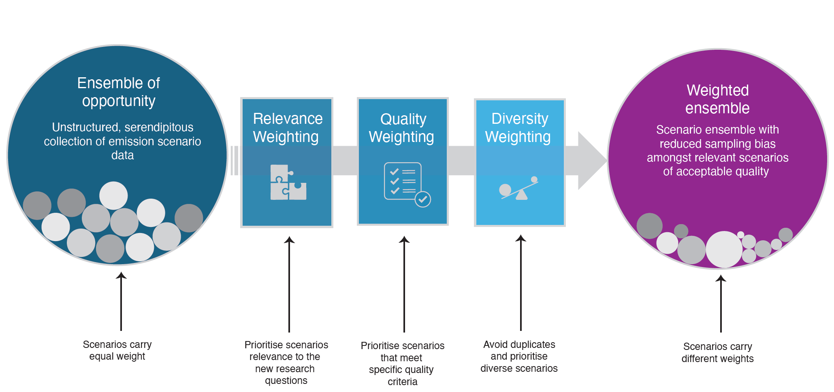

**Figure 1 | A scenario weighting framework for the analysis of scenario ensembles of opportunity.** Schematic showing how the unstructured, serendipitous collection of evidence in a scenario ensemble of opportunity can be translated in a weighted ensemble, accounting for a scenario’s relevance, quality and diversity.

## Relevance weighting

Analysing and re-using scenario data is only sensible once a corresponding research question is defined. A key step in generalised scenario weighting is therefore to define question-specific relevance weights *R(i)* (Eq. 1). This relevance-weighting term *R(i)* can take multiple forms depending on the research question. For example, it could be strictly binary, including or excluding a scenario *i* based on meeting the question-specific condition *C*:

A straightforward example is whether a scenario limits global warming to within certain temperature bounds15. This condition is critical if the intention is to explore characteristics aligned with keeping warming well below 2°C or 1.5°C with a specific likelihood15,24,25.

However, binary weighting of scenarios based on temperature outcome is only fully defensible if uncertainty around a scenario’s climate outcome can be unambiguously quantified with a single probability distribution. This is typically never the case26. Under such conditions, *R(i)* could also take the form of a continuous function. Consider an example with a threshold *ϑ* provided for a given scenario metric *mi*. *R(i)* can be constructed in a way such that scenarios within the threshold are weighted with unity, and scenarios beyond the threshold are weighted based on their distance to the threshold, for example, using a stretched exponential function with scaling factor *α* and stretching exponent *β* to determine the relevance weight:

Alternatively, scenarios that are *within* a defined threshold *ϑ*, could be weighted based on their distance from it. For example, a user may want adherence to temperature thresholds but may want to apply a risk-based relevance weighting. Here, scenarios further from thresholds achieve a higher ,as they are deemed to have less risk of breaching the threshold.

## Scenario quality weighting

The quality of a scenario is central to consider whether to continue using its information for secondary analysis. However, an assessment of quality is subjective and depends on the research question being explored. For example, accurate historical emissions might be important for understanding how emissions relate to global warming targets, while accurate historical energy system capacities might be important if characteristics of the energy transformation are gleaned from these pathways. Alternatively, quality weighting could be derived from the characteristics of certain models. For example, their treatment or omission of specific technologies of interest. Quality weighting could also be assigned using quantifiable feasibility criteria16,27, obtained from literature or expert judgment or elicitation28. Practically, this could mean down-weighting scenarios with technology pathways or societal changes judged by experts to be outside plausible achievability.

Methods that have earlier been applied to account for climate data projection quality19–22 can be adapted to our new context, by comparing emissions and energy trends in scenarios to recent observations. Scenario quality can be accounted for by implementing a continuous weighting *Qj(i)* between 0 and 1 for each scenario *i*, based on a set of *j* distance criteria *fj(d)* of *k* quality metrics defined between a scenario’s modelled data for a metric (vk,i) and an expert assessments of a set of measures of quality (*Ek*) (Eq. 4).

The IPCC SR1.5 and AR6 assessments did not use a formal method of scenario weighting but applied a scenario quality filtering7,8,17,29, with each scenario effectively assigned *Q(i)* = 0 (excluded) or *Q(i)* = 1 (included). For example, SR1.5 excluded scenarios with negative CO2 emissions from agriculture, forestry and other land-use (AFOLU) in 2020 due to the perceived implausibility of AFOLU CO2 emissions becoming negative within two years of the report’s publication7,17. In addition, SR1.5 excluded a further 30 scenarios from its analysis of global and sectorial emissions evolutions (see Table 2.4 and Figure SPM.3 in ref. 5) for having greenhouse gas emissions in 2010 outside the range of historical estimates. Other parts of the report that explore scenario dimensions orthogonal to global and sectorial emissions evolutions, include all scenarios. In both above-mentioned cases, *fj(d)* would take a functional form that returns 1 when a scenario variable in a given year falls inside a set range and zero when not.

## Weighting based on scenario diversity

Scenario diversity provides a metric of distance or proximity between scenarios. It equally requires expert judgment and a clear research question to identify relevant variables. For example, to explore emissions statistics consistent with limiting global warming to a specific level, considering the diversity in scenarios’ emission evolutions could be sufficient. For questions possible energy system configurations compatible with a specific climate goal, another set of variables could be selected for determining that diversity.

We use an adapted version of the method to estimate effective repetitions in Earth System Model projections19,20 that uses a Gaussian function:

where Sii’ is a similarity distance metric between two scenarios *i* and *i'* for a single variable, and is taken as a root-mean-square difference between two time series; and *σS*is the “radius of scenario similarity”20. If two scenarios *i* and *i'* are exactly the same, *Sii’* = 0 and *D(i)* = 2, weighting each model as 1/2. Eq. (5) can be generalised to compare scenario similarity across *N* variables:

where *bn* are relative contributions of each variable to the total diversity weighting that sum to 1 across all variables *n*. Besides selecting *σS,n* for each variable *n*, Equation 6 also requires the selection of the appropriate constants *bn*. The simplest case could be to set *bn* = 1/*N*, but some variables may be more important than others in relative terms.

Other ways of defining *D(i)* could also draw on an analysis of the underlying energy model fingerprint of mitigation scenarios30 or alternative ways of conceptualising distance, for example, through principal component analysis31.

## Dependencies between weighting applications

Our method uses multiple weights which can interact with one another. For instance, the definition and calculation of quality *Q(i)* and diversity *D(i)* weights is informed by the scope of relevance weights *R(i)* being applied. Further, quality and relevance can be multidimensional and individual dimensions can be weighted differently. As a result, a set of final scenario weights and the analysis outcomes of the weighted dataset may change based on the scope of the research question. Our weighting method allows this dependency to be communicated in a structured and transparent way.

Consider two analyses of interest. The first interrogates a scenario dataset based on temperature outcomes. In this case, *Q(i)* may comprise weights based on proximity to historical emissions inventories. However, for a research question focused on investments needed to achieve a given temperature limit, *Q(i)′* would additionally weight scenarios based on their historical investment and near-term investment outcomes. In this case, *Q(i)* differs from *Q(i)′* and secondary analysis outcomes will reflect these different research demands.

## Application to IPCC AR6 database

To illustrate the usefulness of our weighting framework, we apply it to the scenarios included in the IPCC AR6 Scenario Database10 and look at the influence on key scenario assessment outcomes of the AR66. We focus this illustrative application on scenarios that limit warming to 1.5°C with no or limited overshoot (C1), the subset of C1 scenarios also reaching net zero greenhouse gas (GHG) emissions over the course of the 21st century25 (C1a), and scenarios that return warming to 1.5°C after a high overshoot (C2). We apply binary question-specific relevance weights R(i) to select the desired scenarios, although we apply alternative continuous relevance weighting approach in Supplementary Results 1. We apply a continuous quality weighting, , based on the IPCC AR6 vetting procedure29 (see Methods). Diversity weighting D(i) considers the similarities between scenarios in four key dimensions (emissions, economy, mitigation strategy, and energy) and a total of 15 variables (Methods Table 1). However, due to correlations between variables, this is reduced to 8 variables used in the main results (see Methods). We primarily focus on diversity weighting, the most complex dimension, considered separately from continuous quality weighting for interpretability. The outcomes represent one set of weighting inputs; further examples are discussed in the Supplementary Information.

## reweighting sensitivity of benchmarks

Applying question-specific relevance, quality, and diversity weighting to the IPCC AR6 database reveals a range of final weights across scenarios (Fig. 2a). Higher-emission scenarios in the IPCC AR6 scenario database (IPCC categories C3 and higher) show less relative diversity than mitigation scenarios in the C1 and C2 categories and hence see a larger number of scenarios with lower weights. This feature can be understood when considering that the scenario compilation by IPCC AR6 aimed to explore diverse mitigation futures. Quality weights (Fig. 2d) have a spikey distribution, as scenarios from specific intercomparison projects and models have harmonised input data.

Visually, 2050 CO2 emission and peak warming ranges of C1 and C2 show little change (Figs. 2b, c e & f). Under diversity weighting, the median 2050 CO2 emissions reduces slightly for C1 and C1a, while all categories show wider IQRs and 5th-95th ranges (Fig. 2b). Median peak temperatures barely change for C1 and C1a but fall for C2; all categories have wider interquartile ranges. For quality weighting (Figs 2e & f), the impact on medians varies by categories.

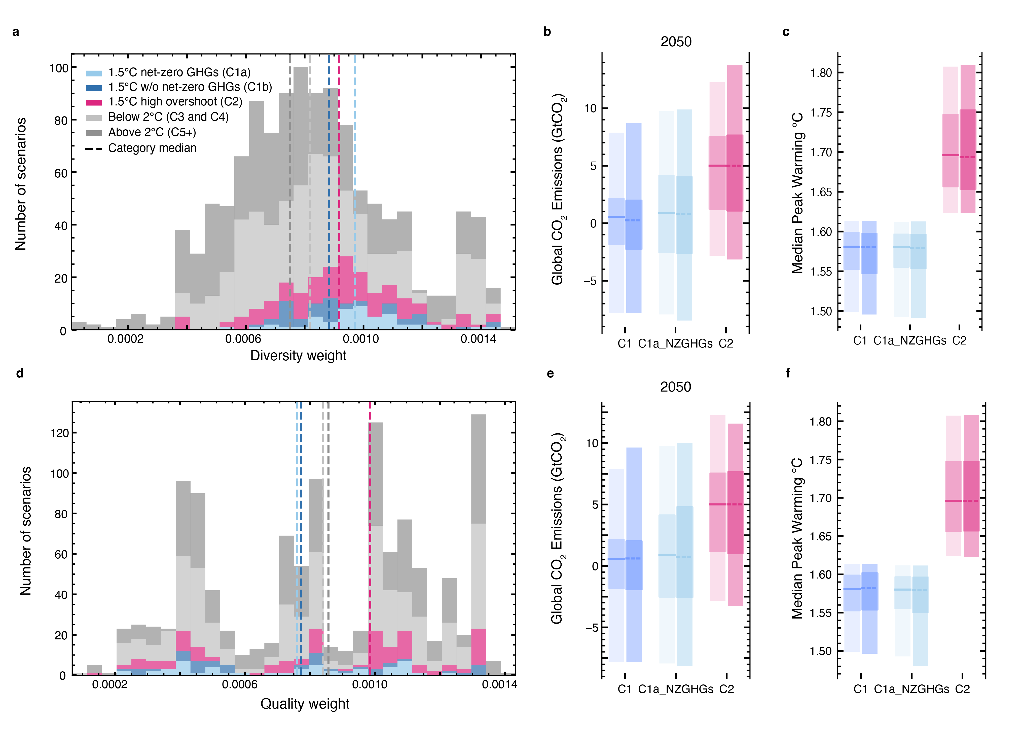

**Figure 2 | Diversity weighting of scenarios available in the IPCC AR6 scenario database. a.** Diversity weights *D(i)* for scenarios per IPCC scenario category; **b.** unweighted and diversity weighted distributions for 2050 CO2; **c.** unweighted and diversity weighted distributions for median peak temperature (MAGICCC); **d** Quality weights *Q(i)* for scenarios per IPCC scenario category; **e.** unweighted and diversity weighted distributions for 2050 CO2  **f.** unweighted and quality weighted distributions for median peak temperature (MAGICCC). For panels b, c e and f, the darker coloured distributions for each temperature represented weighted ones. The wides shaded ranges represent the 5th and 95th percentiles, with the narrow ones the interquartile range. Weighted and unweighted quantiles are computed using the same non-interpolating approach (see Methods).

For other outcomes of our diversity weighting, including net-zero years (Fig. 3a) and the trajectory of certain variables (Fig. 3b-l, Supplementary Figures 2 & 3), some metrics show noteworthy changes. For C1 scenarios, the median year of reaching net-zero GHG emissions is advanced by a decade (from 2098 to 2088); but C1a scenarios, it is advanced by much less (2071 to 2068). For C2 scenarios the median net-zero GHG date moves earlier, but by less than a year, while the upper quartile reduces by 2 years (from 2084 to 2082). Median net-zero CO₂ years remain virtually unchanged (C1/C1a <1 year earlier; C2 unchanged).

For many of the 15 variables reported by all scenarios, changes to timeseries are negligible (Supplementary Figures 2 & 3). However, some mitigation-relevant variables show visible changes, highlighting where the ensemble is sensitive to diversity weighting. For example, the median and upper quartile values for carbon capture and storage (CCS) are higher after 2050 for C1 and C2. In 2070, medians are 13% higher for C1 and 7% for C2.

The data suggest that reweighting has greater impact where outcomes are widely spread and unevenly distributed. However, this is not systematic. For example, Primary Energy from Gas for C1 scenarios (Fig. 2d) exhibits a wide interquartile range, with the 75th percentile diverging from the median after 2050, but little change in the reweighted ensemble. This highlights that the effect also depends on similarity within and across temperature categories in the wider ensemble, and the parameters used for determining similarity (Supplementary Results 2).

Although only illustrative, these observations indicate that a more balanced consideration of the diversity of the scenario evidence suggests small but measurable changes to climate action benchmarks. Given the observed change in net zero GHG years, the IPCC AR6 scenario assessment would be understood as conservative regarding the mitigation action compatible with Paris Agreement aligned targets.

We explore further diversity weighting procedures and their impact in the Supplementary Results 2. These further explorations highlight which changes broadly persist across inputs (e.g., reduction in net zero GHG years, higher CCS), and which vary depending on the choice of weighting inputs (e.g., Primary energy from Gas). The impact of continuous quality weighting is shown in Supplementary Figs. 5–6.

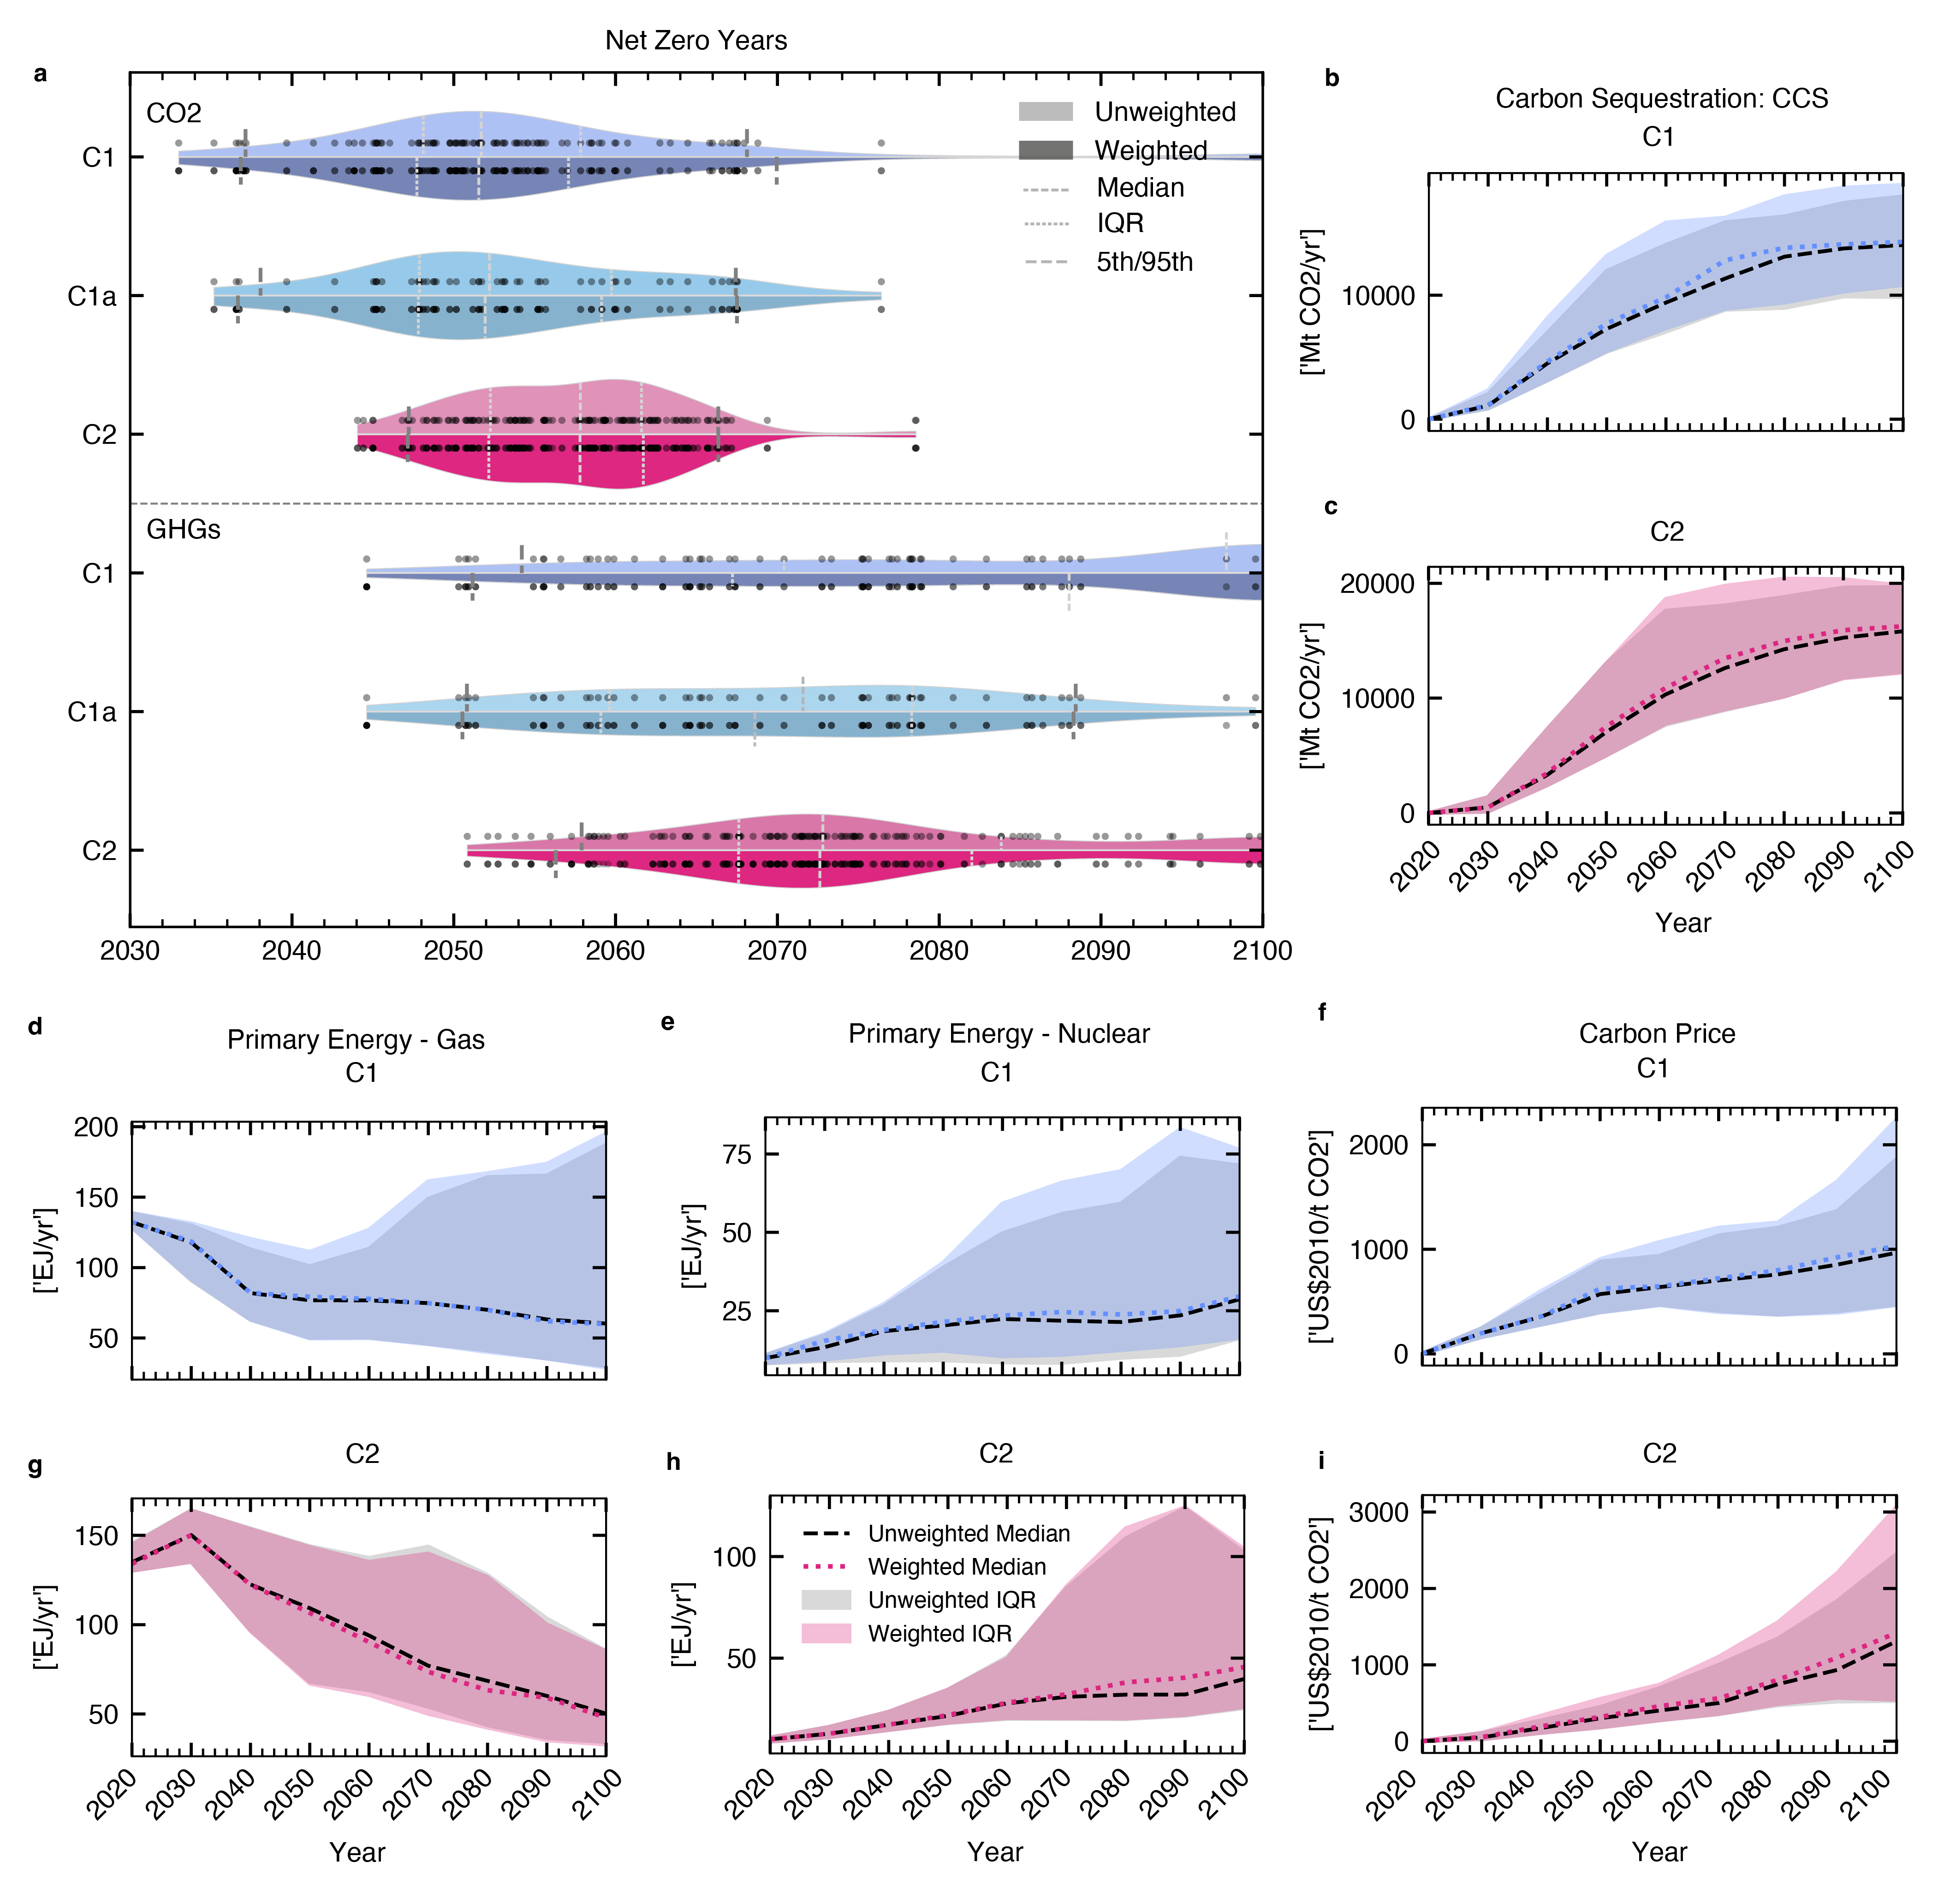

**Figure 3 | Key assessment quantities in diversity weighted and unweighted scenario category ranges from the IPCC AR6 scenario database. a.** Net zero CO2 and greenhouse gas (GHG) years; **b.** Carbon sequestration from carbon capture and storage for C1; **c.** Carbon sequestration from carbon capture and storage for C2 **d. & e,** Primary Energy from Gas timeseries for C1 and C2 respectively; **e & h**, Primary Energy from Nuclear timeseries for C1 and C2 respectively; **f & I,** Carbon Price timeseries for C1 and C2 respectively. Our plots show data from three scenario categories: scenarios limiting warming to 1.5°C with no or limited overshoot (IPCC AR6 category C1) n=97, the subset of these scenarios also reaching net zero GHG emissions in the second half of the century (IPCC AR6 category C1a) n=50, and scenarios returning warming to below 1.5°C in 2100 after a high (0.1–0.3°C) overshoot (IPCC AR6 category C2) n=133. Individual scenarios are shown as dots. Violins show unweighted and weighted distributions, respectively, which are distinguished through lighter and darker areas. Dashed and dotted lines in the plots indicate key distribution statistics as defined by the legend in panel **a**. For timeseries plots, the coloured shaded areas represent the interquartile range of the reweighted distribution, with grey shaded areas representing the unweighted interquartile range. The coloured dashed lines represent weighted medians, whilst black dashed lines represent unweighted medians, as shown in the legend in panel h. Weighted and unweighted quantiles are computed using the same non-interpolating approach (see Methods).

## Exploring robustness

It is well-established that IAMs behaviour is to a large degree determined by their framework logic, structure and input assumptions32,33. Equally, model intercomparison studies use harmonised scenario design assumptions, dominating key scenario insights34. Understanding whether insights are robust across model typographies, structures and scenario design assumptions is therefore important. Jack-knife resampling allows the estimation of bias of a test statistic and has been previously applied to scenario ensembles35. Such a test calculates how outcomes *Vd* vary across the ensemble, *E* when iteratively removing scenarios according to each instance *d* in resampling dimension *D* (e.g., removing specific modelling frameworks or types of models, or intercomparison studies).

We perform two jack-knife resampling tests to see how outcomes are affected by the diversity reweighting of scenarios in the ensemble. We first test the sensitivity to unbalanced contributions by model frameworks, and second, the sensitivity to contributions by projects (Fig. 4, and Supplementary Tables S1 and S2).

In some instances, diversity weighting alters ensemble sensitivity to removal of projects or model frameworks, including narrower ranges under our weighted examples. For example, 5th and 25th percentiles for net-zero GHG years for C1 scenarios (Fig 4a). This indicates that these earlier shifts from diversity weighting are robust. Some statistics show greater variability post-weighting. For example, the C1 median net zero GHG for project and model, and the 95th percentile of net zero CO2 year for project show wider ranges than their unweighted counterparts (Fig 4a, b). This indicates greater sensitivity to model or project composition, and less stability in the weighted ensemble. However, there are nuances when interpreting wider ranges. For C1 GHG medians, the lower bound of the project-based jack-knife values occurs when removing the ENGAGE project. ENGAGE is the most prevalent C1 project, with its share reduced in the weighted ensemble (Fig 5b). In this instance, the reduced lower bound value (and thus wider range) for the weighted jack-knife median net-zero GHG year reflects higher diversity weights of scenarios from less prevalent projects.

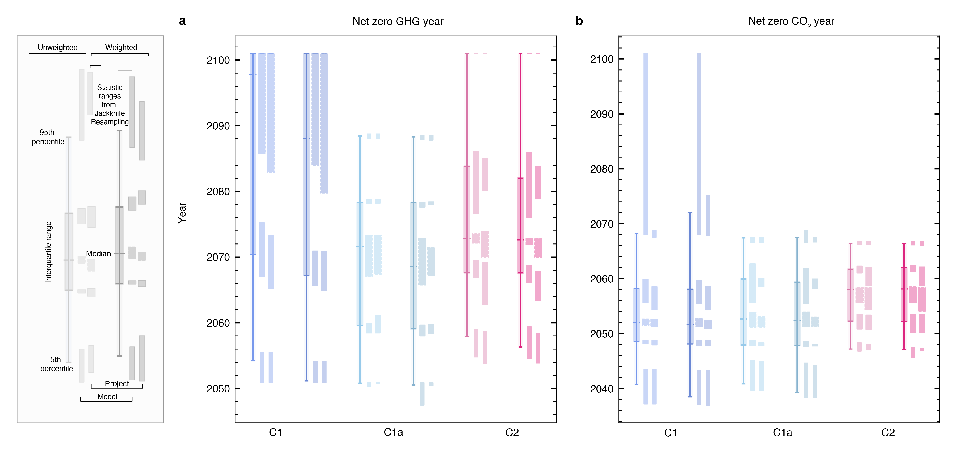

**Figure 4 | Interplay between weighting of scenario ensembles and jack-knife resampling outcomes. a.** Net zero GHG years; **b.** Net zero GHG years CO2. Statistics are documented in the figure legend. For each statistic of the unweighted and the weighted ensemble, the jackknife resampling illustrates the potential variation in the estimators. The jack-knife resampling based on model framework iteratively excludes each respective larger modelling framework group as reported in the IPCC AR6 database. The resampling based on project iteratively excludes each respective contributing project or individual study. See Supplementary Tables S1 and S2 for a list. Both weighted and unweighted quantiles are computed using the same non-interpolating approach (see Methods).

## Impact on model and project dominance

Accepting that scenario similarity is due in part to commonality of model or intercomparison study, one would expect weighting to even out relative contributions to summary statistics. Our illustrative diversity weighting indeed shows small but consistent adjustments in the relative contributions of projects and models (Figs 5b, d). Applying the Herfindahl-Hirschman Index (HHI)1, an indicator used for measuring concentration of dataset components, model framework, model type and project dominance are reduced for both C1 and C2 categories (Supplementary Figure 11). For model framework and model type, there is an 8-9% reduction in HHI in C1 and C2 categories, and for project, an 11% reduction in the HHI for C1, and a 6% reduction for C2. A reduced HHI means less dominance of large components (see Methods). Sensitivity tests show these general trends are robust to a range of alternative inputs to the diversity weighting scheme (see Supplementary Results 4).

Focussing on the impact on specific scenarios, the prevalence of models and projects can explain which scenarios achieve high or low weights. The top-10 diversity weighted scenarios for both C1 and C2 originate from a model framework and/or project with low prevalence (Figs 5a&c). Likewise, the bottom-10 scenarios originate from either a project or model with high prevalence, or in many instances both. The bottom five scenarios (Fig. 5c) for C2 originate from MESSAGE (second most prevalent model for C2) and are variants with 50 Gt CO2 differences (400-650) in full-century carbon budgets (Fig. 5). In our C2 top 10, there are three scenarios which are also carbon budget variants; however, these come from the AIM model framework (3rd least prevalent) and have wider carbon budget differences (100Gt CO2).

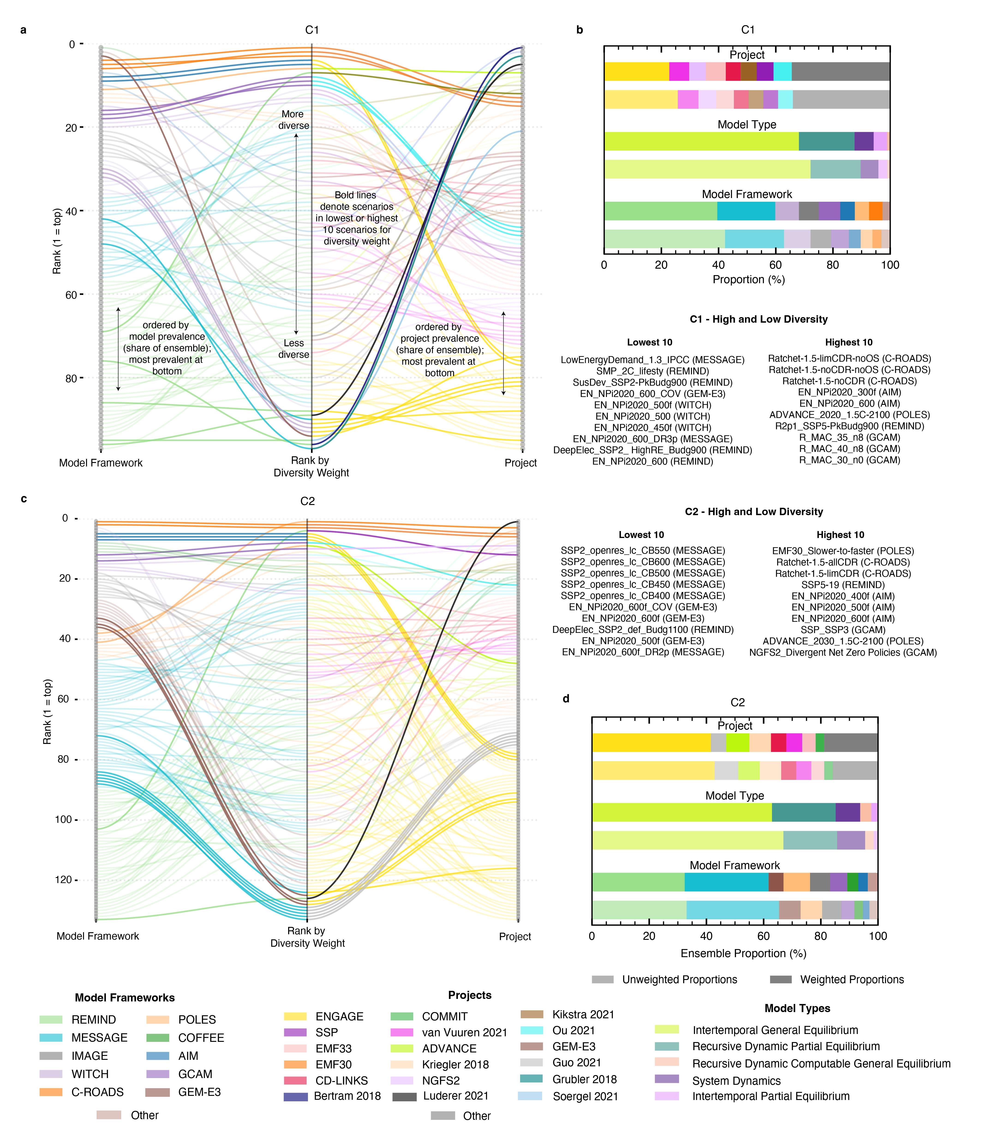

**Figure 5 | Insights into how scenarios diversity weighted according to model frameworks and projects. a.** connectedrank plot showing C1 scenarios grouped by model (left ranking), diversity weight (central ranking) and project (right ranking). **b** the unweighted and weighted proportions of each project, model type and model framework for C1 scenarios; **c,** equivalent connected rank plot from panel **a**, but for C2 scenarios; d, stacked bars showingthe unweighted and weighted proportions of each project, model type and model framework for C2 scenarios. For the rank plots (panels **a** & **c**), in the left and right ranks, scenarios are grouped with the largest model/project at the bottom. Thicker more visible connection lines are shown the for scenarios in the highest or lowest 10 scenarios by diversity weighting. For the stacked bars (panels **b** and **d)** the lighter shaded bars are unweighted, and the darker shaded bars are diversity weighted. Only the 8 largest shares shown, with other grouped together as “Other”, as visible on the key.

## Reweighting for improved scenario assessment

This weighting framework presented here is designed to be simple and transparent. Whilst our illustrative application to AR6 scenarios is by no means exclusive, it does indicate that reweighting for diversity may lead to a strengthening of certain climate action milestones. Additionally, sensitivity analysis indicates that some changes, such as earlier net zero GHG years for C1 scenarios, are maintained across a range of diversity weighting inputs. The diversity weighting procedure reduces the dominance of prevalent models and intercomparison studies; with this finding being robust to a range of sensitivities (Supplementary Results 4).

The framework could be applied to explore further dimensions. Scenario quality or relevance weighting could be used to integrate questions around sustainable development within pathway assessments, for example, with limits for biomass or carbon-dioxide removal as part of a the broader United Nations Sustainable Development Agenda5,36,37. Alternatively, it could be used to consider questions regarding feasibility of scenario pathways across multiple dimensions16,38. Finally, reweighting of scenario ensembles might also be useful to improve methods that derive relationships from scenario ensembles, such as for the completion of missing species of GHG emissions39.

Our weighting framework, offers promise,but Its flexibility allows it to be applied to specific research questions. However, e judgmentexistsinterpretation ofIn this paper, we demonstrate how some expert judgments might influence outcomes. Although flexibility of our framework is a strength, proliferation of weighting approaches could lead to reduced accessibility and transparency. It is therefore vital that there is clear and consistent reporting of applied weightings and justification of their underlying expert judgments. Acknowledging this, the structured nature of the framework can help to ensure the necessary expert judgment is well-guided and transparent.

Moreover, transparency is essential: scenario data have a range of applications, some of which may incentivise selective presentation. Without a clear framework and best-practice guidance, re-weighting scenario ensembles could enable parties to present ensemble statistics to suit a preferred narrative.

Scenario ensembles are commonly used to calculate headline statistics, rather than to present the intricacies of their composition 1. Our reweighting framework aims to improve the robustness of ensemble statistics, allowing the user to remove redundancy, and apply tailored quality and relevance criteria. However, even after reweighting, scenario ensembles are incomplete, and there is thus a danger that reweighting may produce a different kind of overconfidence in ensemble statistics1. Indeedreweighting , and caution must therefore accompany its use.

As similar scenarios are down-weighted by diversity weighting, a balance must be struck between accounting for repeated instances of scenarios that are fundamentally similar, whilst retaining useful information from areas in which they differ. Near-identical scenarios but from a different model framework may not represent redundancy, for example. Scenarios that push the boundaries of conventional thinking and are less similar to more traditional modelled pathways, including emerging efforts to implement circular economy and degrowth storylines or those that focus on low energy demand40,41 are likely to be weighted higher and contribute more to category statistics under a weighted assessment. The drawback of this is that potential novel and emerging scenario approaches might over-emphasise scenarios with technologies at the boundaries of realism. Indeed, diversity weighting in isolation could incentivise the creation of such scenarios in unintended ways. There is a need to explore extremes and novel approaches1, but not without practical consideration of feasibility.

All three dimensions of the weighting framework that jointly cover aspects of relevance, quality and diversity should be carefully considered. At the same time, scenario ensemble assessments also need to reflect on the meaning and usefulness of headline statistics that this framework improves. In that sense, we here present a first approach that can contribute to a larger toolbox of improved methods and approaches for scenario assessment but the role of experts will remain as important as ever.

## Methods

Here we provide the weighting specifications for the illustrative application of the framework to the IPCC AR6 database10. Integrating expressions for all weighting components, the application-specific scenario weighting equation becomes:

#### Relevance Weighting

For analysis of scenarios that limit global warming to 1.5°C with no or limited overshoot (IPCC AR6 category C1), or scenarios that return warming to 1.5°C after a high overshoot (IPCC AR6 category C2), respectively, we apply binary question-specific relevance weights *R(i)* that select scenarios with the specific global warming characteristics as defined in IPCC AR66.

And separately:

C1a scenarios are a subset of C1 scenarios in which net GHG emissions reach zero levels in the second half of the century.

#### Quality Weighting

We test a continuous quality weighting *Q(i)*, adapted from the IPCC AR6 procedures and reported in Table 11 in ref. 29 (reproduced in Supplementary Table S3). For each quality criterion, , that specified a range, we use the distance of the modelled value, for each scenario from the reference value, ,normalising by the interquartile range, , of the scenarios

We then use a Guassian function to produce the continuous weight, , for each criterion, :

This yields a weight of 1 when there is perfect agreement with the reference value. We treat each criterion evenly and combining to give a single quality weighting:

The weighting procedure is applied to vetted scenarios adhering to specific temperature outcomes (see relevance weighting). In our illustration it is therefore applied scenarios that meet other vetting criteria that do not provide an acceptable range.

#### Diversity Weighting

Diversity weighting *D(i)* accounts for variations in 15 variables across four key dimensions (emissions, economy, mitigation strategy, and energy, Methods Table 1). These 15 variables are part of the minimum data requirement for a scenario to be considered as part of the IPCC AR6 ensemble and therefore available for each scenario. The illustrative variable weights *bn* for each variable are a subjective choice and here chosen to put equal weights on each of the four key dimensions. Sub-weighting of the variables in each group attempts to limit the overall influence of variables that are similar in nature and could bias the total, or puts weight on more important variables. For example, in the Energy category, the six Primary Energy variables combined are worth the same as the single variable of Final Energy. In the Emissions category, the aggregate weighting of all non-CO2 emissions variables equals that of CO2, recognising that CO2 is the primary anthropogenic driver of climate change42.

Although not applicable here, scenarios that do not report all variables can also be included by rescaling coefficients *bn* for the variables that are available. This rescaling is first achieved within each variable group, or across all remaining groups if one variable group would end up having no reported variables. The sum of *bn* is always unity.

Acknowledging the subjectivity in variable weighting, we also explored using only energy variables, as well only emissions variables from our selection (Supplementary Results 2). To account for correlation between variables, we adjusted our variable weights using a correlation matrix and hierarchical clustering (Supplementary Methods 1). This results in a set of ‘correlation adjusted’ variable weights, with a reduced number of 8 variables utilised following correlation assessment and clustering. We adopt an even weighting across the variables as we preserve emphasis on originally higher weighted variables in selection of our representative cluster variables (see Supplementary Methods 1 & Table 1). We present our correlation adjusted weights in the main paper but also show results from our full set of variables in Supplementary Results 2.

Our conceptual choice of *σS,n* (radius of similarity) between two scenarios is guided by expert judgment and should be seen as an informed yet illustrative choice rather than a conclusive one. We define *σS,n* as the root mean square difference between different IAMs running the same SSP-RCP combination available from ref. 9 using 10-year timesteps from 2020 to 2100. We explore a range of values between the minimum and maximum of the SSP-RCP model differences, selecting a value that achieves a high median spread in diversity weights across our variables, whilst ensuring a relatively even impact across all variables (Supplementary Results 2). For no-policy, no-mitigation or “business-as-usual” scenarios, we remove the Mitigation group variables from determining the distances of *σS,n* as these are zero by definition in these scenarios.

#### Calculation of Weighted Quantiles

Quantiles are calculated without interpolation. Reported quantile values are the lowest scenario values equal to or above the quantile. When applying to weighted distributions, quantiles are calculated using the same approach, but rather than scenarios having an equal weight in the distribution, scenarios contribute according to its assigned weight. Therefore, the cumulative sum of weights is used to identify the quantile threshold.

#### Calculation of Herfindalh-Hirschman Index (HHI)

To quantify changes in model or project concentration in our unweighted and weighted ensembles, we use the Herfindalh-Hirschman Index1. This has historically been used for measuring market concentration in economics but can be applied more broadly to a dataset to understand dominance of components. It is defined by the sum of squared shares of each component:

Where is the of the component in relation to the total. A higher HHI value indicates increased dominance of single components.

**Table 1 | Variable for estimation of scenario similarity or diversity.** The 15 variables used from the IPCC AR6 Database10 to determine the scenario similarity. For each variable the importance weighting assigned to each is shown (equation 6) along with the *radius of scenario similarity .* The group that each variable applies to is shown, with each group having a total weight of 1/4.

|  |  |  |  |  |
| --- | --- | --- | --- | --- |
| **Variable** | **expert** | **correlation adjusted** |  | **Group** |
| CO2 Emissions | 1/8 | 1/8 | 2.75 GtCO2 yr-1 | Emissions |
| CH4 Emissions | 1/24 | 0 | 31.2 MtCH4 yr-1 |  |
| N2O Emissions | 1/24 | 1/8 | 0.898 MtN2O yr-1 |  |
| Sulphur Emissions | 1/24 | 0 | 8.48 MtSO2 yr -1 |  |
| Consumption | 1/8 | 1/8 | $41664 bn (2010) | Economy |
| GDP (PPP) | 1/8 | 1/8 | $3983 bn (2010) |  |
| Carbon Capture & Storage | 1/8 | 1/8 | 2811 MtCO2 yr-1 | Mitigation |
| Carbon Price | 1/8 | 1/8 | $19.9 (2010) |  |
| Primary Energy: Oil | 1/48 | 0 | 35.7 EJ yr-1 | Energy |
| Primary Energy: Gas | 1/48 | 0 | 36.7 EJ yr-1 |  |
| Primary Energy: Coal | 1/48 | 0 | 28.5 EJ yr-1 |  |
| Primary Energy: Nuclear | 1/48 | 1/8 | 9.74 EJ yr-1 |  |
| Primary Energy: Biomass | 1/48 | 0 | 18.1 EJ yr-1 |  |
| Primary Energy: Non-Biomass Renewables | 1/48 | 1/8 | 23.7 EJ yr-1 |  |
| Final Energy | 1/8 | 0 | 40.7 EJ yr-1 |  |

## Acknowledgments

H.B. acknowledges funding from the Hitachi-Imperial Centre for Decarbonisation and Natural Climate Solutions. C.J.S. was supported by a NERC/IIASA collaborative research fellowship (NE/T009381/1). J.S.K. was supported by the Natural Environment Research Council under grant agreement NE/S007415/1. M.J.G. was supported by funding from the European Research Council (ERC) under the European Union’s Horizon 2020 research and innovation programme (GENIE – grant agreement No 951542). J.R. and H.B. were supported by the European Union’s Horizon 2020 research and innovation programme (ESM2025 – grant agreement No 101003536) and also acknowledge funding from the Bezos Earth Fund through the Scenario Compass Initiative (Grant G-2023-201305841)

## References

Automatic citation updates are disabled. To see the bibliography, click Refresh in the Zotero tab.

# SUPPLEMENTARY INFORMATION

**Supplementary Table S1 | Entities used for jack-knife resampling along the model group dimension.** Models are identified as in the IPCC AR6 scenario database’s meta data10 and model groups as indicated in this table.

|  |  |
| --- | --- |
| **Model Group** | **Model** |
| AIM | AIM/CGE 2.1 |
| AIM | AIM/CGE 2.2 |
| AIM | AIM/Hub-Global 2.0 |
| C-ROADS | C-ROADS-5.005 |
| COFFEE | COFFEE 1.1 |
| GCAM | GCAM 4.2 |
| GCAM | GCAM 5.3 |
| GEM | GEM-E3_V2021 |
| IMAGE | IMAGE 3.2 |
| MESSAGE | MESSAGE-GLOBIOM 1.0 |
| MESSAGE | MESSAGEix-GLOBIOM 1.0 |
| MESSAGE | MESSAGEix-GLOBIOM_1.1 |
| MESSAGE | MESSAGEix-GLOBIOM_1.2 |
| POLES | POLES ADVANCE |
| POLES | POLES EMF33 |
| REMIND | REMIND 1.7 |
| REMIND | REMIND 2.1 |
| REMIND | REMIND-MAgPIE 1.5 |
| REMIND | REMIND-MAgPIE 1.7-3.0 |
| REMIND | REMIND-MAgPIE 2.1-4.2 |
| REMIND | REMIND-MAgPIE 2.1-4.3 |
| WITCH | WITCH 5.0 |
| WITCH | WITCH-GLOBIOM 3.1 |
| WITCH | WITCH-GLOBIOM 4.4 |

**Supplementary Table S2 | Entities used for jack-knife resampling along the project dimension.** Projects and studies are identified as in the IPCC AR6 scenario database’s meta data10.

|  |
| --- |
| **Project** |
| COMMIT  CD-LINKS |
| ENGAGE |
| Fujimori 2020 |
| Holz 2018 |
| SSP |
| Ou 2021 |
| van Vuuren 2021 |
| ADVANCE |
| EMF30  EMF33 |
| Grubler 2018 |
| NGFS2 |
| Kikstra 2021 |
| Strefler 2018 |
| Strefler 2021a |
| Schultes 2021 |
| Baumstark 2021 |
| Kriegler 2018 |
| Bertram 2018 |
| Strefler 2021b |
| Soergel 2021 |
| Luderer 2021  Levesque 2021  Guo 2021 |

**Supplementary Table S3 | Summary of vetting criteria applied in IPCC AR6 and in this study.** Adapted from Table 11 in ref. 29.

|  |  |  |
| --- | --- | --- |
|  | **Reference Value** | **Range (IP range)** |
| Historical emissions (2019 values) | | |
| CO2 total (EIP + AFOLU) Emissions | 44251 MtCO2yr-1 | ±40% (±20%) |
| CO2 EIP emissions | 37646 MtCO2yr-1 | ±20% (±10%) |
| CH4 emissions | 379 MtCH4yr-1 | ±20% (±20%) |
| CO2 emissions EIP 2010-2020 % change | - | +0% to +50% |
| CCS from energy 2020 | - | 0-250 (100) MtCO2yr-1 |
| Historical energy production (2020 values) | | |
| Primary Energy | 578 EJ | ±20% (±10%) |
| Electricity: nuclear | 9,77 EJ | ±30% (±20%) |
| Electricity: solar and wind | 8.51 EJ | ±50% (±25%) |
|  |  |  |

**Supplementary Results 1 | Implementation of Risk-Averse Relevance Weighting Variation**

In the main text, our relevance weighting application to AR6 scenarios adopts a binary weighting based on assessed temperature category. Here we present an illustrative example of a weighting approach that maintains categorisation by temperature outcomes but places a higher weighting on ‘lower-risk’ scenarios within each. Here, our definition of risk is focused on global warming outcomes and is based only to the metric(s) used for temperature categorisation. Our risk-averse relevance weighting is defined by

where is a binary indicator (1 if scenario is within the temperature category, 0 otherwise), is the weight of the assessment metric for categorisation,; and is the scenario value of the assessment metric. This uses an S-curve, with the slope defined by , greater down weighting occurs closer to the category threshold, and reduced upweighting further away from the median, .

We apply this relevance weighting approach to scenarios in the C1 and C2 temperature categories, both of which use the same temperature categorisation metrics (P33 peak warming and median warming in 2100) but differ based on their level of overshoot (Supplementary Figure 1). Under this example, we assume that a user wishes to main integrity of existing temperature categorisation; hence the explicit division between C1 and C2. When we apply a risk-averse relevance weighting, as would be expected, a more stringent CO2 emissions trajectory is seen for both categories (Supplementary Figure 1c and f).

This is an illustrative example of how a continuous relevance weighting based on a user’s needs could be applied. This could be further adapted based on the context, for example placing more weight on a particular temperature categorisation metric.

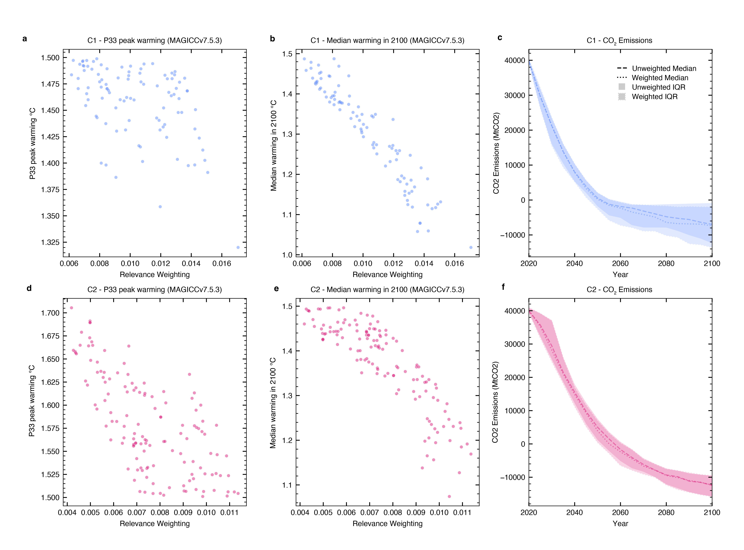

**Supplementary Figure 1 | Figures showing implementation of risk-averse relevance weighting.** Panels a and b shows C1 scenarios overall relevance weighting plotted against peak warming and median peak warming respectively. Panel c shows the weighted and unweighted CO2 emissions trajectories for C1 scenarios. Panels d, e and f mirror the preceding panels but for the C2 scenario subset.

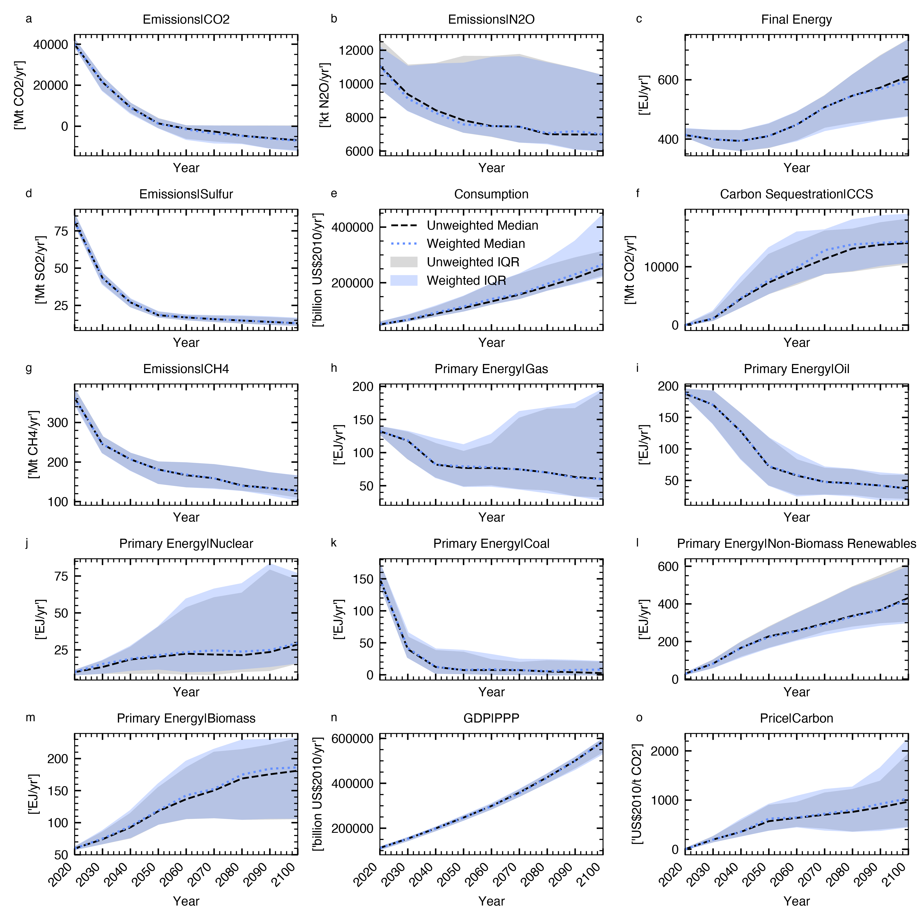

**Supplementary Figure 2 | Timeseries of variables C1 diversity reweighted** Panels a-o show each of 15 variables reported by all scenarios, comparing the median and interquartile range for the weighted and unweighted distributions. The black dotted lines represent unweighted medians, the blue dotted lines weighted medians. Grey and coloured shaded areas are the interquartile ranges for the unweighted and weighted distributions, respectively (key shown in panel e, IQR=Interquartile range).

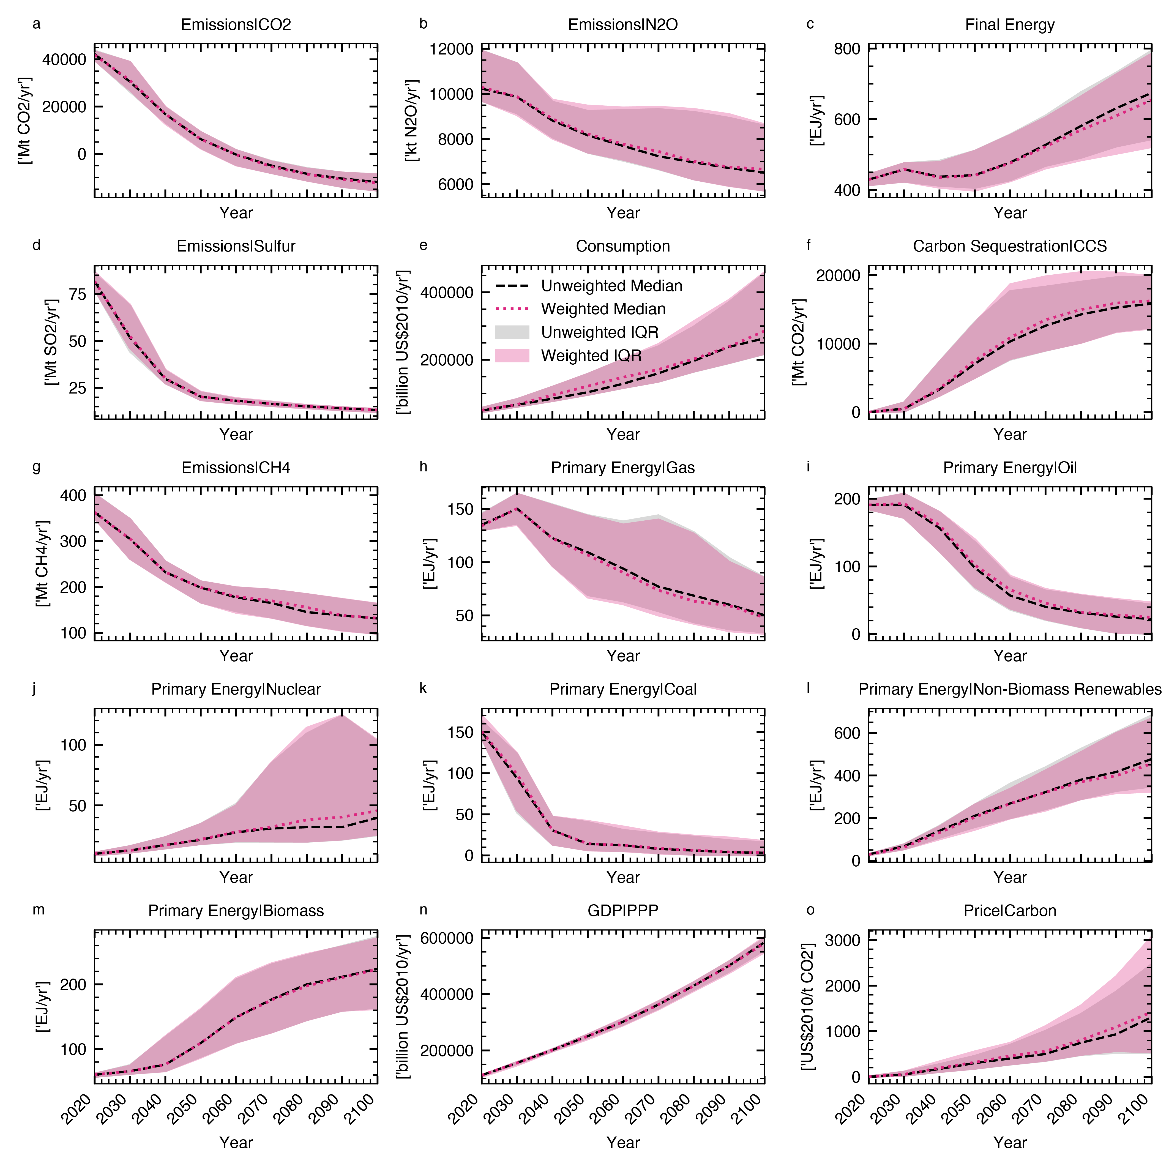

**Supplementary Figure 3 | Timeseries of variables C2 diversity reweighted** Panels a-o show each of 15 variables reported by all scenarios, comparing the median and interquartile range for the weighted and unweighted distributions. The black dotted lines represent unweighted medians, the blue dotted lines weighted medians. Grey and coloured shaded areas are the interquartile ranges for the unweighted and weighted distributions, respectively (key shown in panel e, IQR=Interquartile range).

**Supplementary Results 2** | Sensitivity of climate action benchmarks to different variable weights and sigma values

Here we explore a range of different variable weighting schemes combined with different sigma values. This sensitivity analysis is not intended to be comprehensive; but demonstrates how adjusting certain weighting parameters alters the outcomes. Further we can identify changes in ensemble medians that maintain the directionality regardless of inputs used.

We explore the following weighting of variables used:

* ‘Expert’: variable weights based on expert judgment across 15 core variables reported by all scenarios. Variable weighted reported in Table 1.
* ‘Correl’: correlation adjusted weights, with only 8 variables used (See Supplementary Methods 1 and Table 1)
* ‘Energy_only’: inclusion of only the energy category variables under our expert weight scheme, so the energy group weight becomes 1.
* ‘Emissions_only’ inclusion of only the emissions category variables under our expert weight scheme, so the emissions group weight becomes 1.

For each of these sets of variable weights, we test 5 sets of sigma values between a fraction of the minimum of model differences of the same RCP-SSP combination to the maximum (see Supplementary Results 3).

Firstly, there ensemble changes that are directionally maintained regardless of the weighting inputs, and those that are not (Supplementary Fig. 4). These include, earlier median net-zero GHGs for C1, increased cumulative CCS for C2, reduced cumulative gas for C2, or increased cumulative coal use for C1 and C2. The median net zero CO2 year for C1 and C2 are earlier across all tested inputs, but for most the movement is minor (Supplementary Fig. 4a and c) Adjustments to variable weights and sigma values naturally changes the emphasis of what defines diversity in the database. observing changes that remain across a range of inputs highlights signals that are robust across variables, while others are sensitive to methodological choices and would vary depending on the question being asked.

We can see in the data patterns relating to choice of sigma values, for example some quantities exhibiting bigger changes at the high or low ends of our sigma choices. This is clear for CCS for example, which has a greater upward shift at higher sigma values across our variable weight choices. Our selection of groups of sigma values at intervals means, that the spread of diversity weights for variable adjusts differently between sigma intervals (Supplementary Figure 7). As such, some variables exhibit an increased spread above our central chosen sigma (0.2). This choice was based on an even spread in diversity weights across all variables. Opting for a different choice represents a greater unevenness in the spread across our 15 variables (Supplementary Results 3). So, while stronger impacts for specific quantities can be seen at lower or higher sigma values, these reflect a weighting configuration that disproportionately emphasises certain variables which see a greater spread at higher or lower sigma values. Depending on the research question, however, if fewer variables are of interest, sigma values could be adjusted to maximise spread in those dimensions.

Finally, we can observe some features in the data between variable weight schemes. For example, when applying the emissions only variable weights, we see that for all but the lowest sigma interval, there are larger reductions in the C2 CO2 and GHG net zero years, when compared to using a variable weight scheme that includes all variable types. Under this scheme, diversity is only being defined by differences in emissions trajectories, and therefore scenarios diverging on their emissions pathways will achieve greater weight. For C2, this leads to a more pronounced effect on our test quantities.

Whilst we observe some features in our data that are robust to adjustments in sigma values and variable weights, as would be expected, these results highlight that how diversity is defined may impact the outcomes for the ensemble.

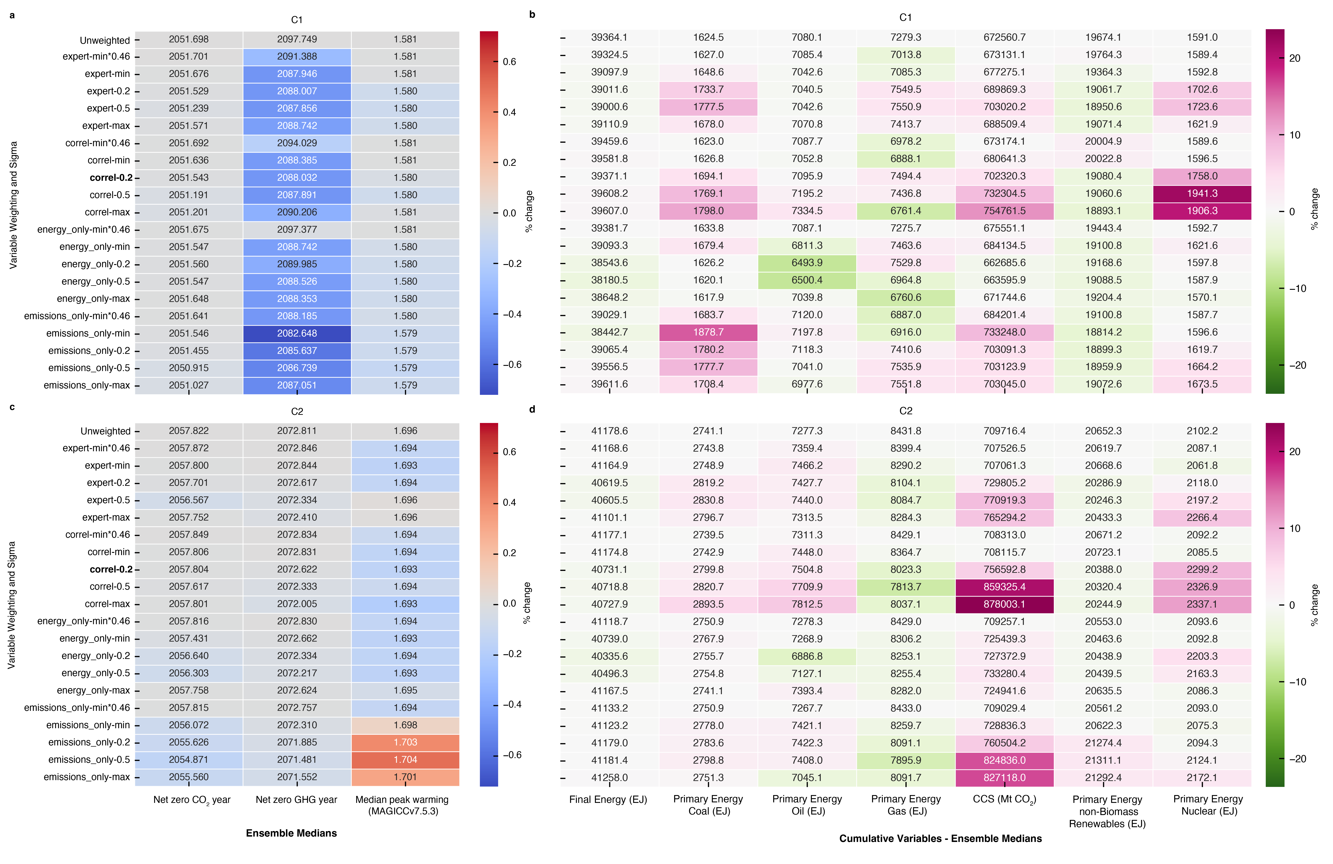

**Supplementary Figure 4** | **Heatmaps showing impact of alternative diversity weighting inputs on ensemble outcomes (medians).** Panel **a** and **c** showing impact on net zero years and peak temperature for C1 and C2 scenarios respectively; panels **b** and **d** showing impact on a range of variables, median values and cumulative 2020-2100 for C1 and C2 scenarios respectively. Cell colours are derived from the % difference from the corresponding unweighted values, shown in the top row. For panels a and c, red denotes increases when compared with unweighted ensemble medians, and blue decreases. For panels b and d, pink = increases and green = decreases when compared with unweighted medians. The results presented in the main paper are identifiable as the bold listed item ‘correl-0.2’ on the x axis. For guidance on weighting inputs see description above in Supplementary Results 2.

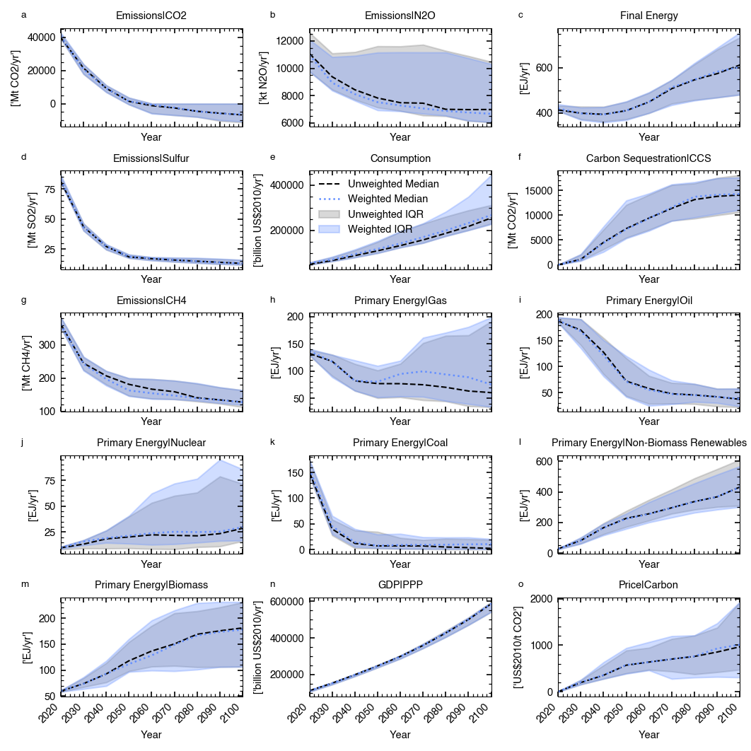

**Supplementary Figure 5 | Timeseries of variables C1 quality reweighted** Panels a-o show each of 15 variables reported by all scenarios, comparing the median and interquartile range for the weighted and unweighted distributions. The black dotted lines represent unweighted medians, the blue dotted lines weighted medians. Grey and coloured shaded areas are the interquartile ranges for the unweighted and weighted distributions, respectively (key shown in panel e, IQR=Interquartile range).

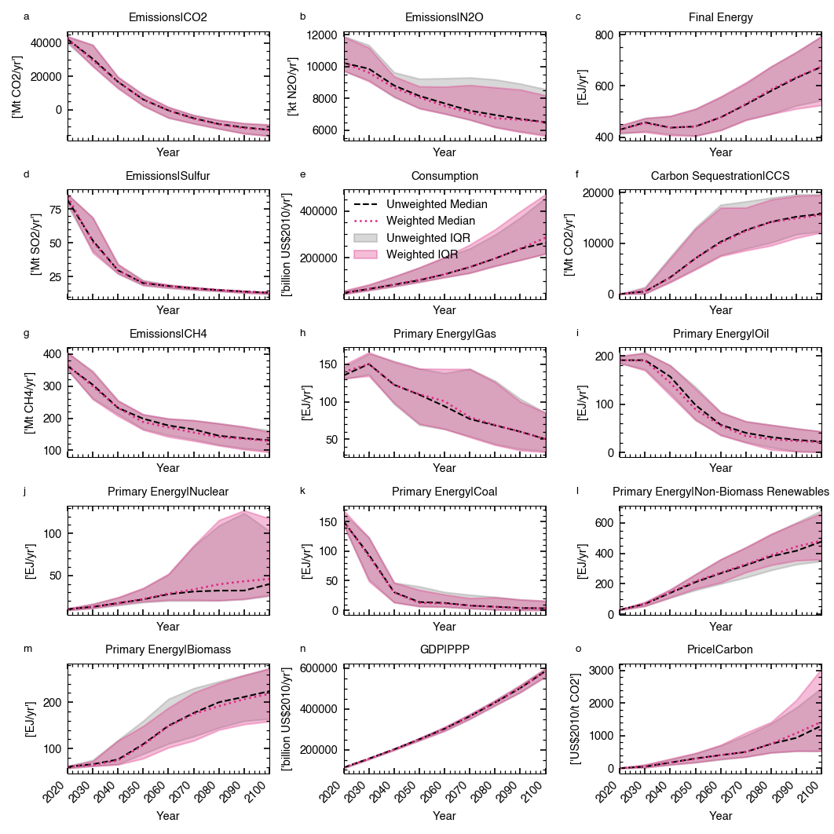

**Supplementary Figure 6 | Timeseries of variables C2 quality reweighted** Panels a-o show each of 15 variables reported by all scenarios, comparing the median and interquartile range for the weighted and unweighted distributions. The black dotted lines represent unweighted medians, the blue dotted lines weighted medians. Grey and coloured shaded areas are the interquartile ranges for the unweighted and weighted distributions, respectively (key shown in panel e, IQR=Interquartile range).

**Supplementary Results 3 | Impact of different sigma values on spread of diversity weights**

The choice for what constitutes scenario similarity is crucial for how the diversity weighting approach operates in practice. Sigma values that are very small relative to ensemble variation, will see only very few scenarios fall within it, this will result in no or minimal reweighting for most scenarios. Conversely, large sigma values relative to ensemble variation will result in scenarios effectively not being reweighted as they are all treated as similar.

Sigma choice will reflect the needs of the user in their application of the weighting procedure. A user may want to implement a specific and known set of sigma values informed by a definition of scenario similarity. This could be guided by distances between certain scenarios. In this context, even if the sigma’s are small in relation to ensemble variation, it could be applied as a robustness check across an ensemble. However, an alternative approach is to test the impact of a range of sigma values with the final choice determined by the impact on the ensemble.

Here, we perform an illustrative example of the latter approach, exploring the impact of a range of sigma values on the spread of weights, by variable. To do this, we stay with our conceptual definition of scenario similarity: the RMS of SSP-RCP combinations, run by different models. We test a range of sigma values between the minimum and the maximum of the SSP-RCP combinations, at 10 percentile intervals to explore the impact on the spread of diversity weights (Supplementary Figure 7). To explore the point at which most variables have seen a collapse in their IQR, we expanded our assessment below the minimum, SSP-RCP model differences testing fractions of the minimum, in a log-spaced grid from 0.1*min to 1*min (6 intervals) (Supplementary Figure 7)

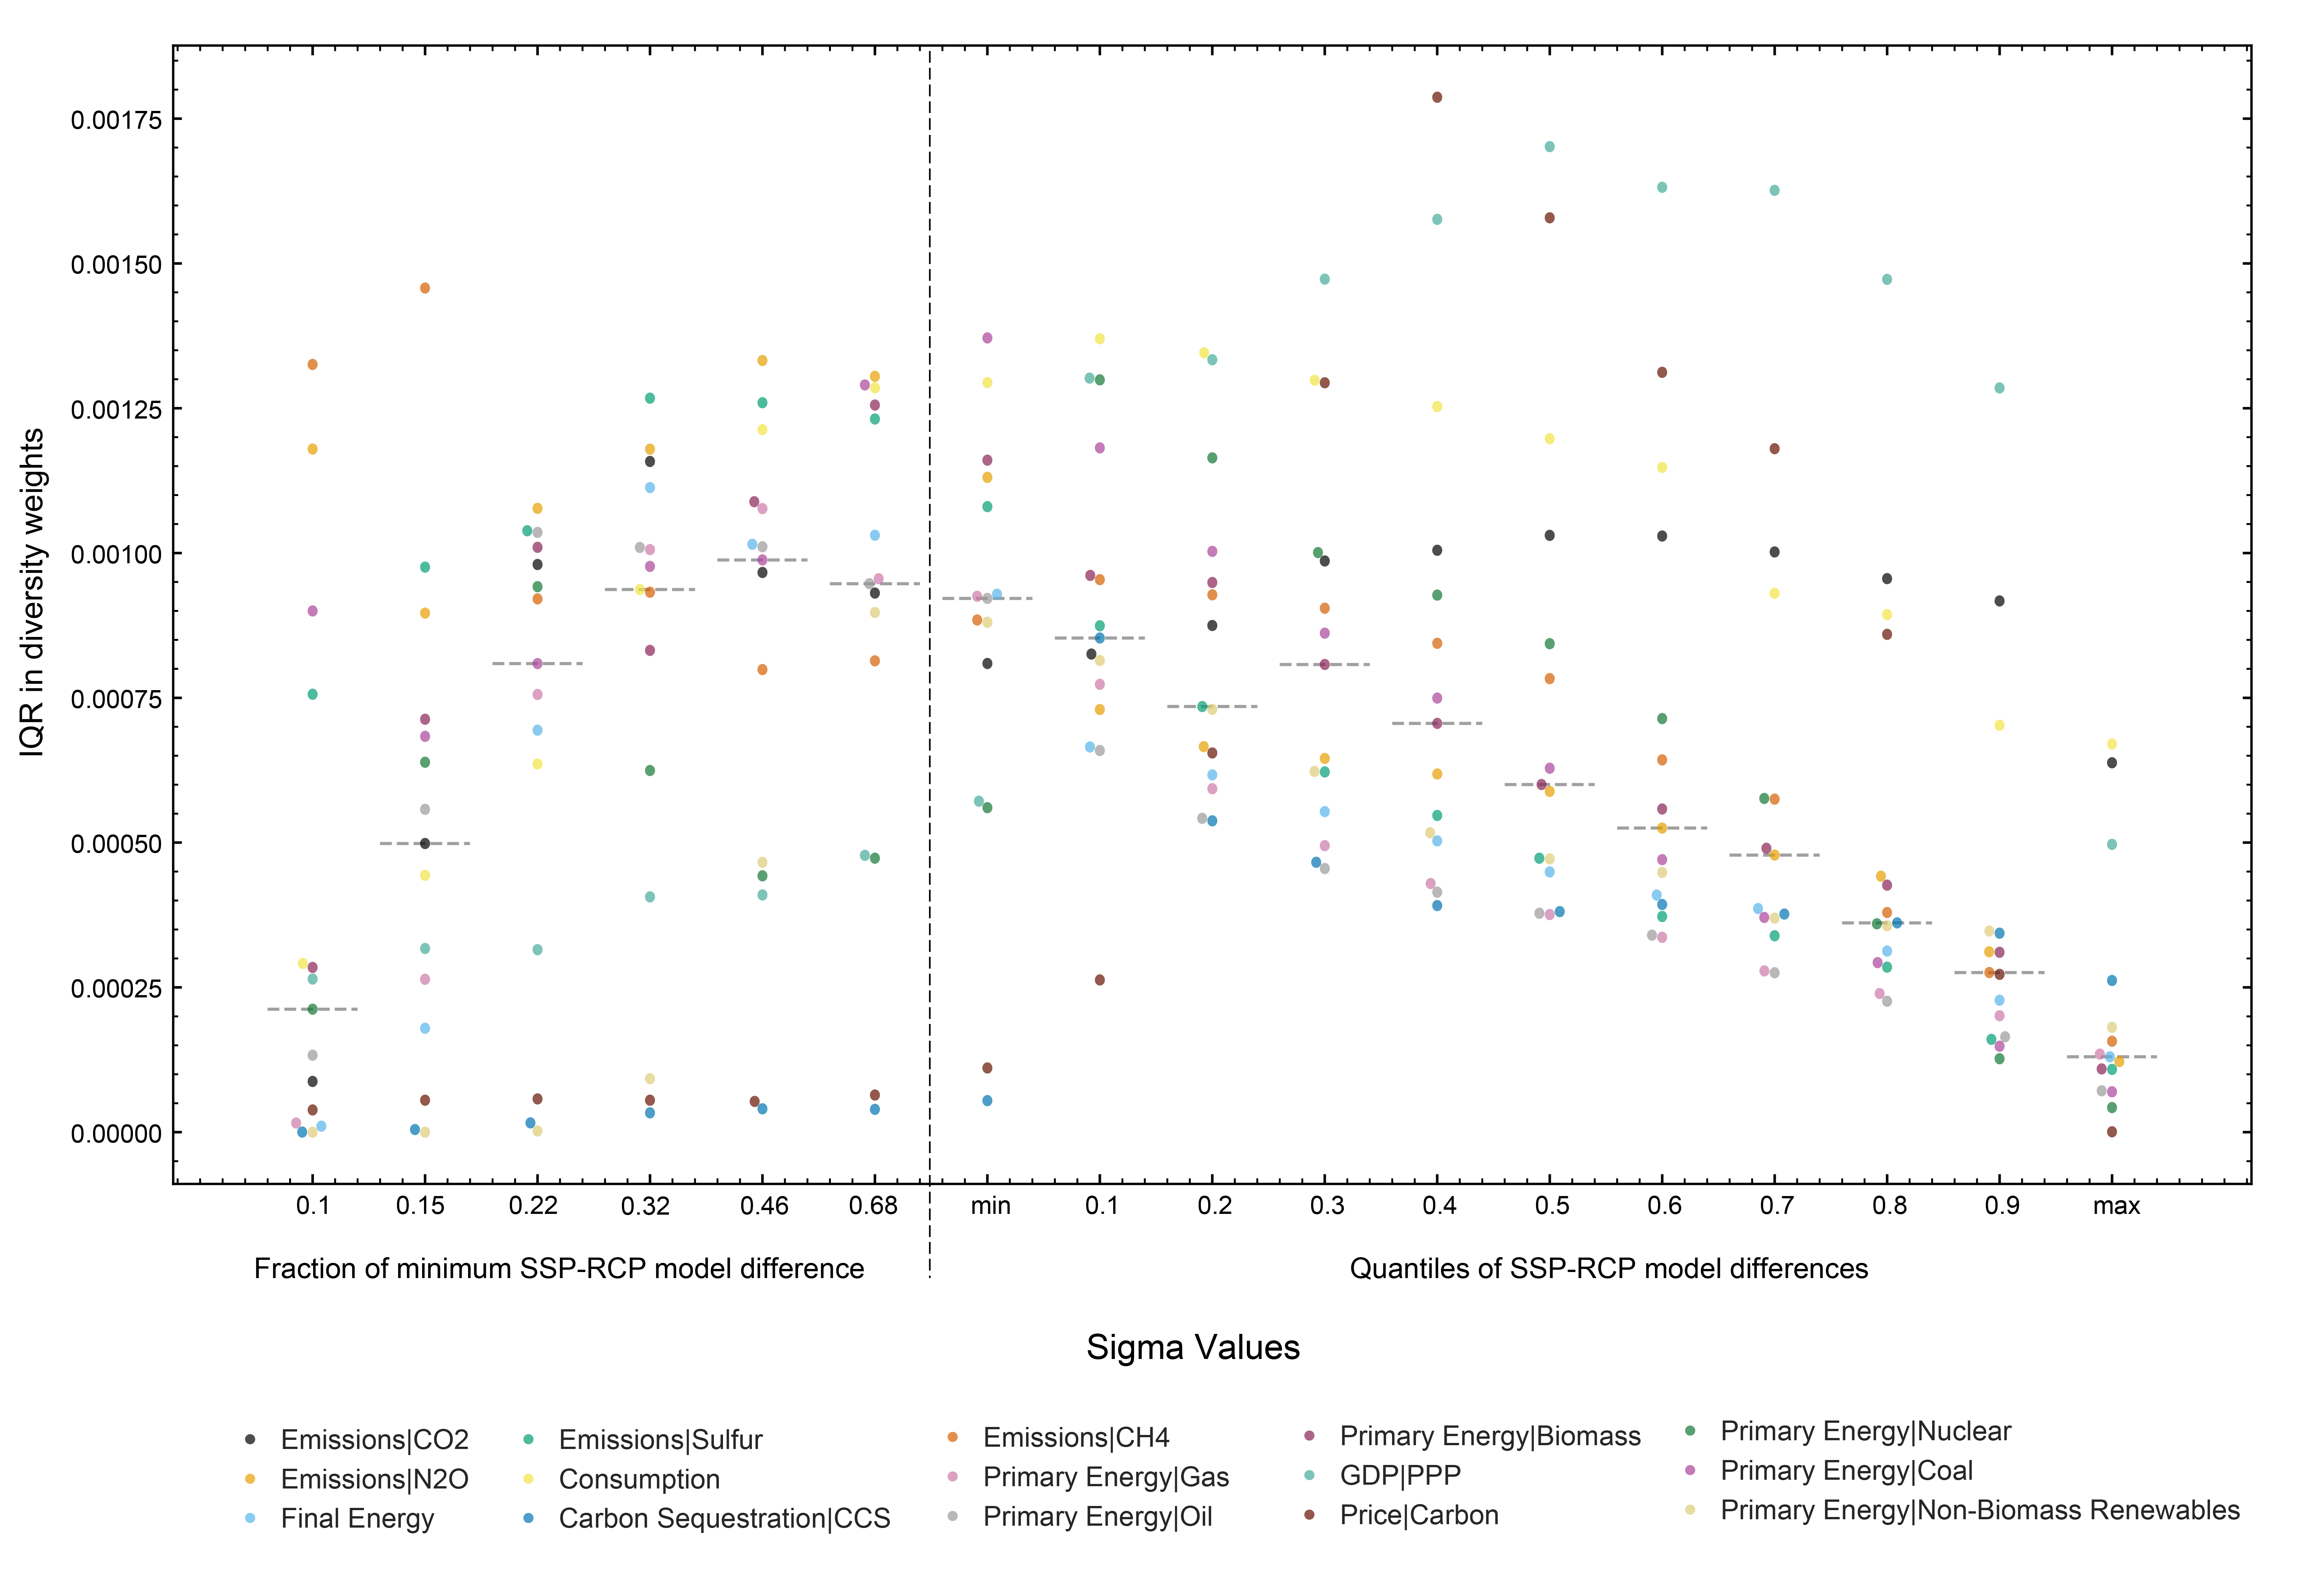

**Supplementary Figure 7 | Impact of sigma values on spread of diversity weights by weighting variable.** Swarm plots showing the interquartile range in the variable-specific diversity weights at a range of sigma values between the maximum and minimum of RMS difference of SSP-RCP combinations run by the same model. Values were taken at 10 percentile intervals and adjusted in tandem with each other. We also show fractions of the minimum, in a log-spaced grid from 0.1*min to 1*min (6 intervals). Median lines shown by grey dotted lines.

As would be expected, the IQR in the diversity weights varies by variable, with the highest median IQR at our 0.46*min set of values (Supplementary Figure 2). The median IQR declines sharply towards the 0.1*min values, however the range increases with some variables (e.g., CH4, N2O) with IQR appearing to be increasing beyond our minimum sigma values. Above the 30th percentile of SSP-RCP model differences, the medians steadily decline, with all variables declining by the max values. Although the maximum median IQR 0.46*min, there is a large range in the IQR values, with some variables, e.g., Carbon Price and CCS where the respective values at this interval have minimal reweighting effect as they are too small. At a higher interval, around the 20th and 30th percentiles, although there is a lower median IQR, the data indicate that all variables are seeing some reweighting. This test of sigma values within a specified range and definition of scenario similarity allows us to stick with the conceptual choice but ensure that the values used will lead to effective reweighting.

Next, taking the diversity weights calculated for each of our variables, before combining, we can explore the impact at the variable level for each set of sigma values. This is important for understanding how sigma values influence each variable and the final reweighted outcomes in the ensemble. Looking at C1 and C2 scenarios (Supplementary Figure 3), we can see that for many variables, regardless of which sigma values used, reweighting would indicate moves likely to represent a strengthening of mitigation action (e.g., more low carbon primary energy and CCS (Supplementary Figure 3, panels j, l, m and f). However, this is not universally true, for example for primary energy from gas and coal, the lower sigma values see the median gas trajectory higher than the unweighted ensemble median.

An important point to recognise is that we perform our diversity weighting and sigma selection across the whole AR6 database. The selection of sigma values to ensure a spread of diversity weights across the ensemble may result in sigma values that have little effect for our subset.

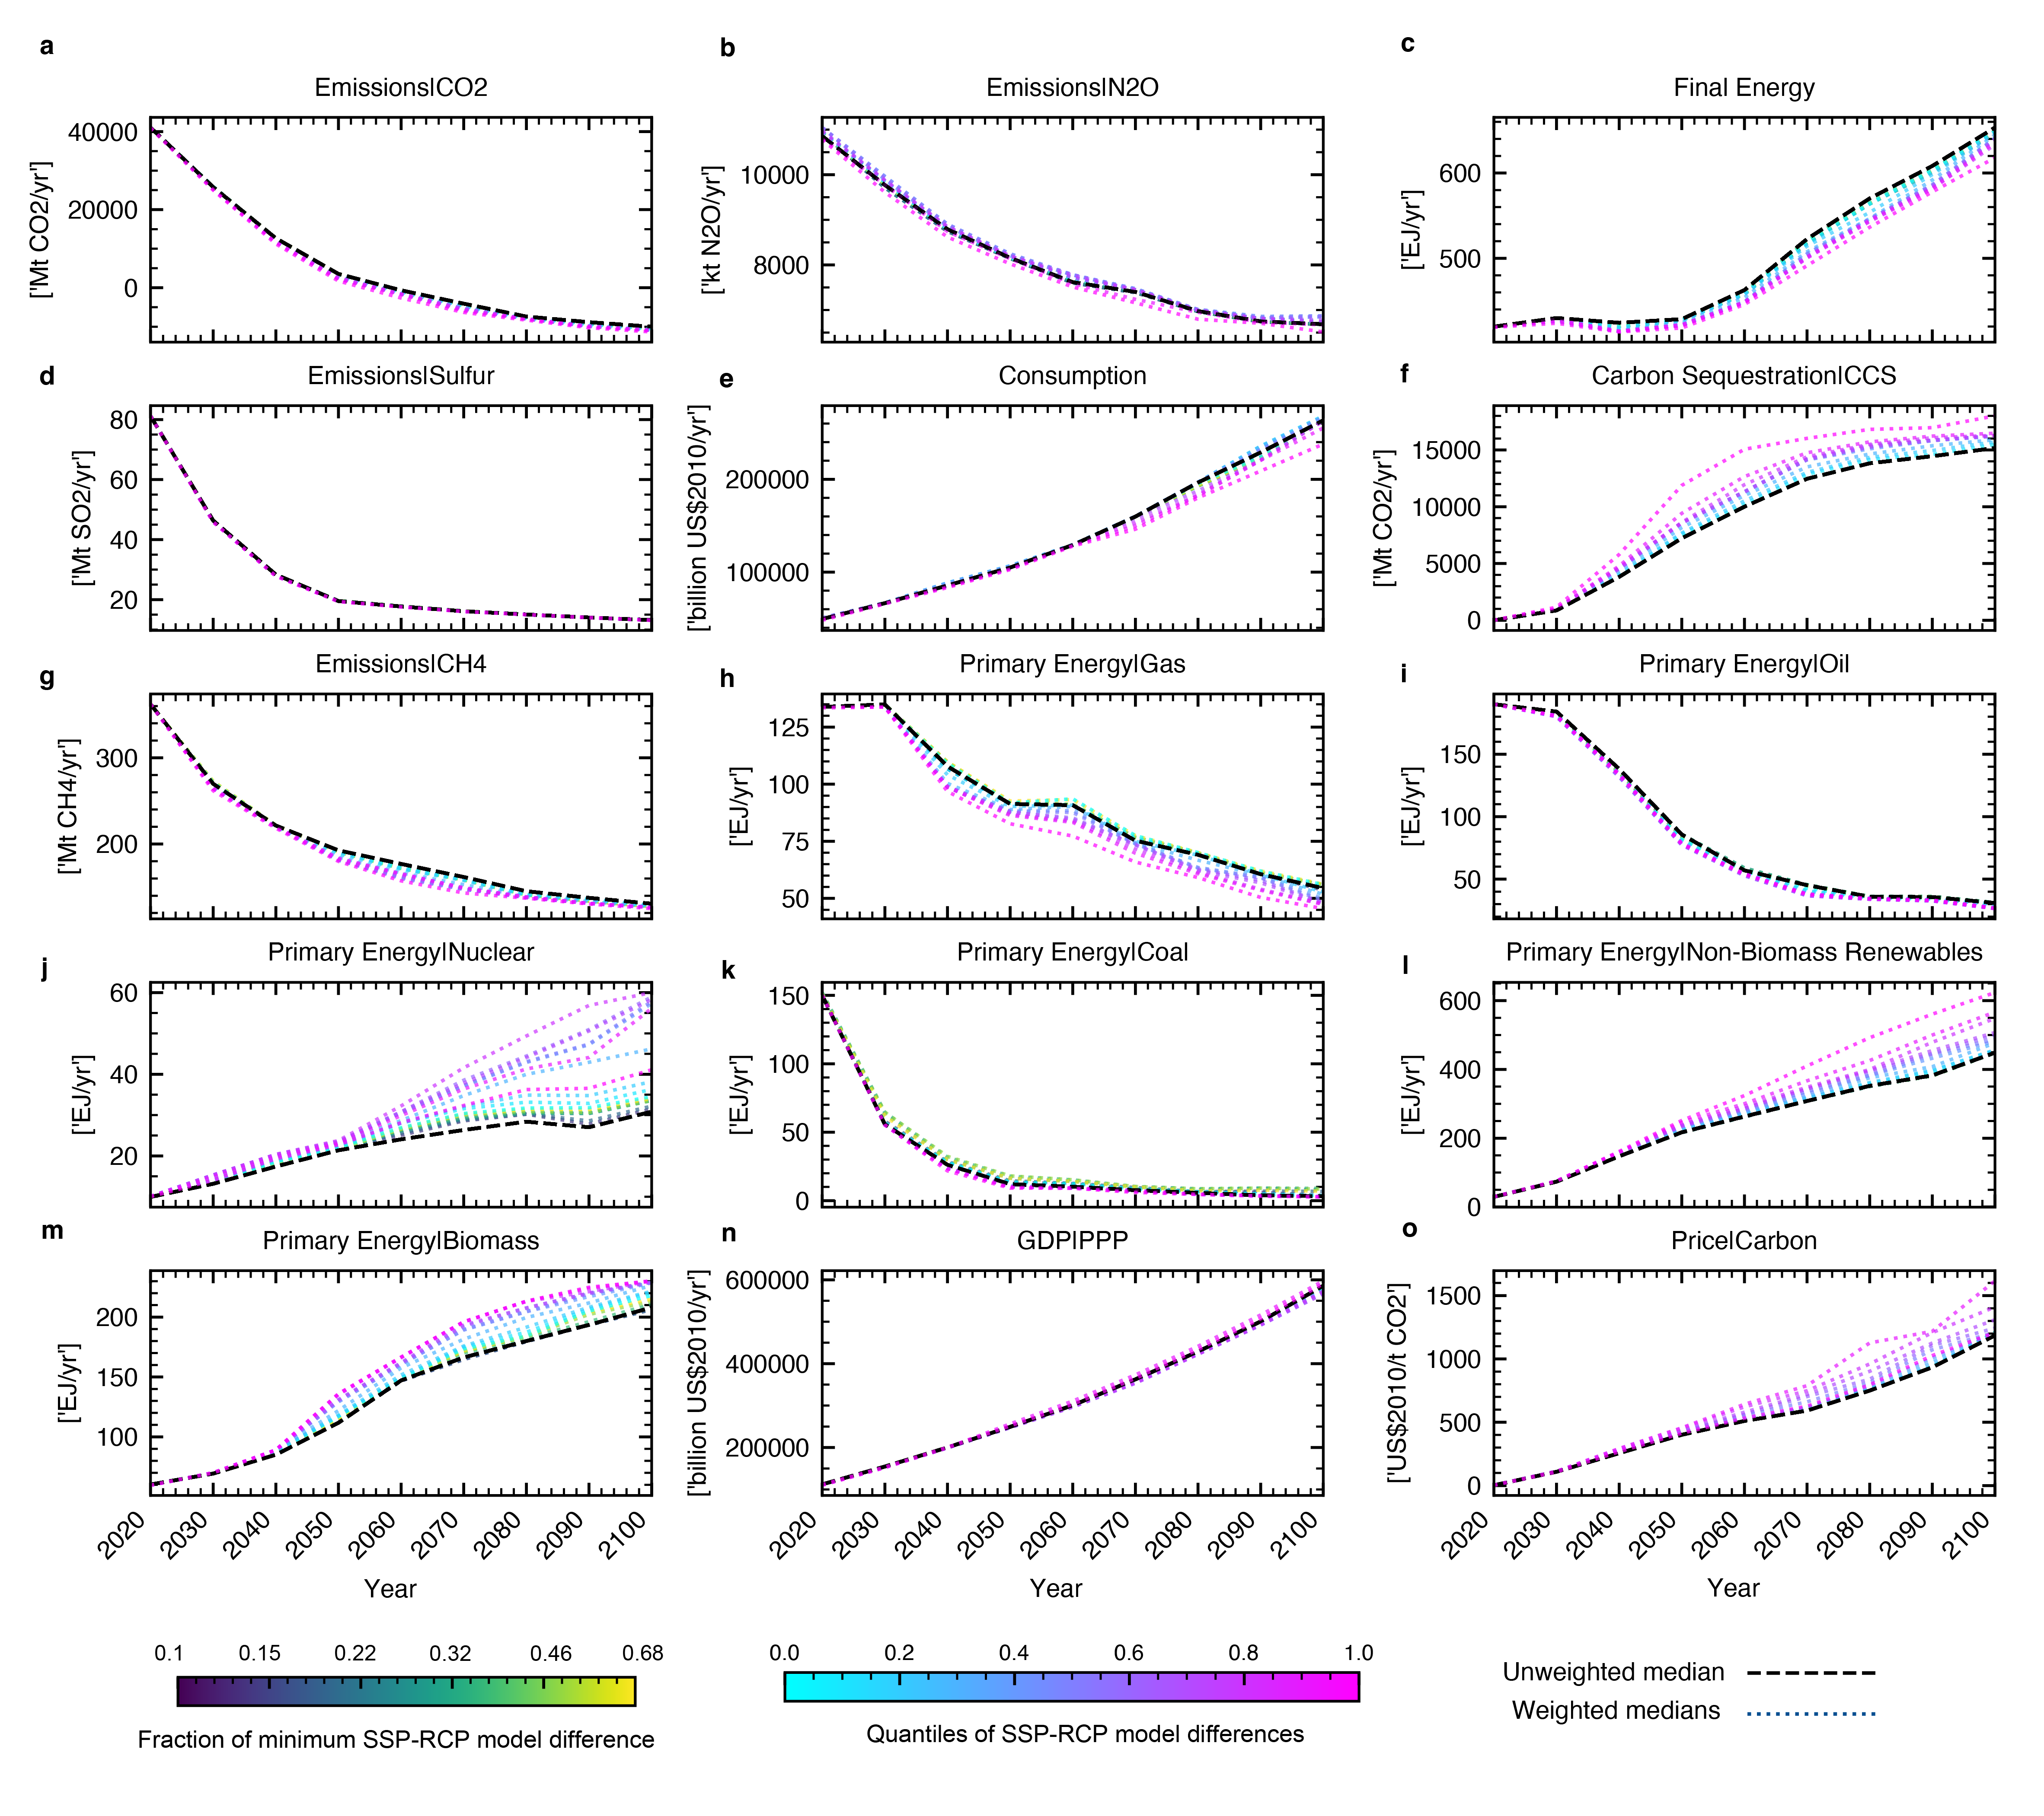

**Supplementary Figure 8 | Impact of sigma values on median timeseries for all C1 and C2 scenarios, applying variables weights to specific variables.** Panels a-o show each of our weighting variables comparing the median of reweighted variables across a range of sigma values, with the unweighted median. Coloured lines represent the reweighted median lines, with the minimum to the maximum of the RCP-SSP model differences shown at each 10 percentile intervals and fractions of the minimum, in a log-spaced grid from 0.1*min to 1*min (6 intervals)

**Supplementary Methods 1 | Calculation of Correlation Adjusted Variable Weights**

Some variables in the database are correlated, meaning that a set of weights might amplify certain signals. Here we perform some simple analysis to derive a set of illustrative variable weights that reduce this effect. To adjust for correlation between our variables, we computed the correlation between our pairs of variables across all vetted scenarios at decadal intervals (2020-2100). We used the mean of the decadal correlations to provide single correlation values for all variable pairs. Variables with correlation above 0.5 are shown in Supplementary Table S4.

**Supplementary Table S4 | Weighting variable pairs with correlations high than 0.6.**

|  |  |
| --- | --- |
| **Pair** | **Correlation** |
| Emissions|CH4 - Emissions|CO2 | 0.756 |
| Emissions|CH4 - Emissions|Sulfur | 0.624 |
| Emissions|CO2 - Final Energy: 0.663 | 0.663 |
| Emissions|CH4 - Primary Energy|Coal | 0.776 |
| Emissions|CO2 - Primary Energy|Coal | 0.801 |
| Emissions|CO2 - Primary Energy|Gas | 0.659 |
| Emissions|CO2 - Primary Energy|Oil | 0.671 |
| Emissions|Sulfur - Primary Energy|Coal | 0.608 |

The absolute correlations were converted into distance metric (Distance = 1 - |correlation|) to be used in the hierarchical clustering process. We used the Scipy hierarchical clustering package to perform clustering [cite]. Clusters were formed using the average linkage method, merging clusters on the mean pairwise distance between cluster members. Looking at clusters between thresholds of 0.4 and 0.5, 0.4 provides only one cluster of more strongly correlated variables, whilst raising the threshold to 0.5 adds further variables to clusters (Supplementary Figure 9 ). We adopt 0.5 for our illustrative use case as it represents greater redundancy removal to be observed in our diversity reweighting results. For each cluster with multiple variables, we select an illustrative variable for each cluster, using the one with the highest weighting in our original weighting scheme. The result is a set of variable weights that reduce redundancy and for variables present, we adopt an even weighting across the variables as we have preserved emphasis on originally higher weighted variables in selection of our representative cluster variables.

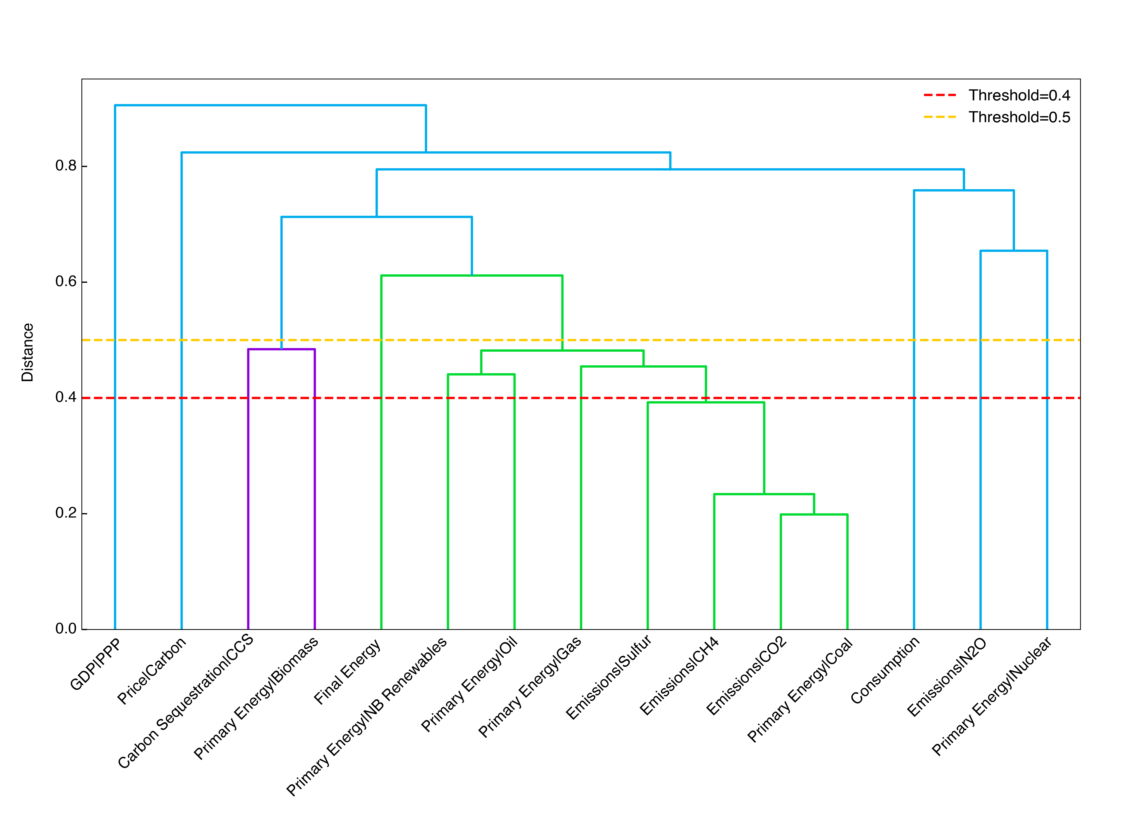

**Supplementary Figure 9 I Dendrogram visualising hierarchical clustering of variables.** Colours are used to describe variables that eventually fall into clusters at different distance thresholds. Dotted lines are used to show the difference in clustering at a threshold of 0.4 and 0.5.

**Supplementary Results 4 |** **Impact of diversity weighting on database characteristics and exploration of scenario weights**

Here, we explore how a range of reweighting approaches impact the distribution of projects, model types and model frameworks and policy category.

Firstly, visualising how database characteristics change in unweighted and weighted ensembles, we show a some two examples of weighting procesdures for our 1.5 degrees scenarios and the database as a whole. We show sigma using the 20th percentile of RMS RCP-SSP model differences, identified as having a weighting impact across variables (see Supplementary Results 2). We combine it with our ‘expert’ variable weighting (see Table 1) (Supplementary Figure 4 panels a-c) and our correlation adjusted weighting (panels d-f) (Supplementary Methods 1). For these weighting schemes, there are modest but visible differences in the unweighted and weighted proportions of project, model type and model framework. Although not universal, it appears the reweighting procedure under these conditions results in more balanced distribution of project, model type and model frameworks. For example, for all subset examples and both the expert and correlation adjusted weights, we see the REMIND model framework with a reduced share of scenarios. For project distribution there is a reduction in the share of the ‘ENGAGE’ project in all but one of our examples. Under our correlation adjusted variable weights, across the whole database, the share of ENGAGE scenarios increases slightly.

Secondly, we test a range of weighting inputs and their impact on the concentration of model frameworks, model types, projects and policy categories. Here we explore the same weighting inputs as in Supplementary Results 2. Although not universal, improvements in project, model framework and model type are robust to a range of alternative inputs for C1 and C2. However, when sigma values are high or low (uneven impact across variables) there are instances where these quantities are worsened. Diversity in scenario policy category is worsened under almost all weighting approaches.

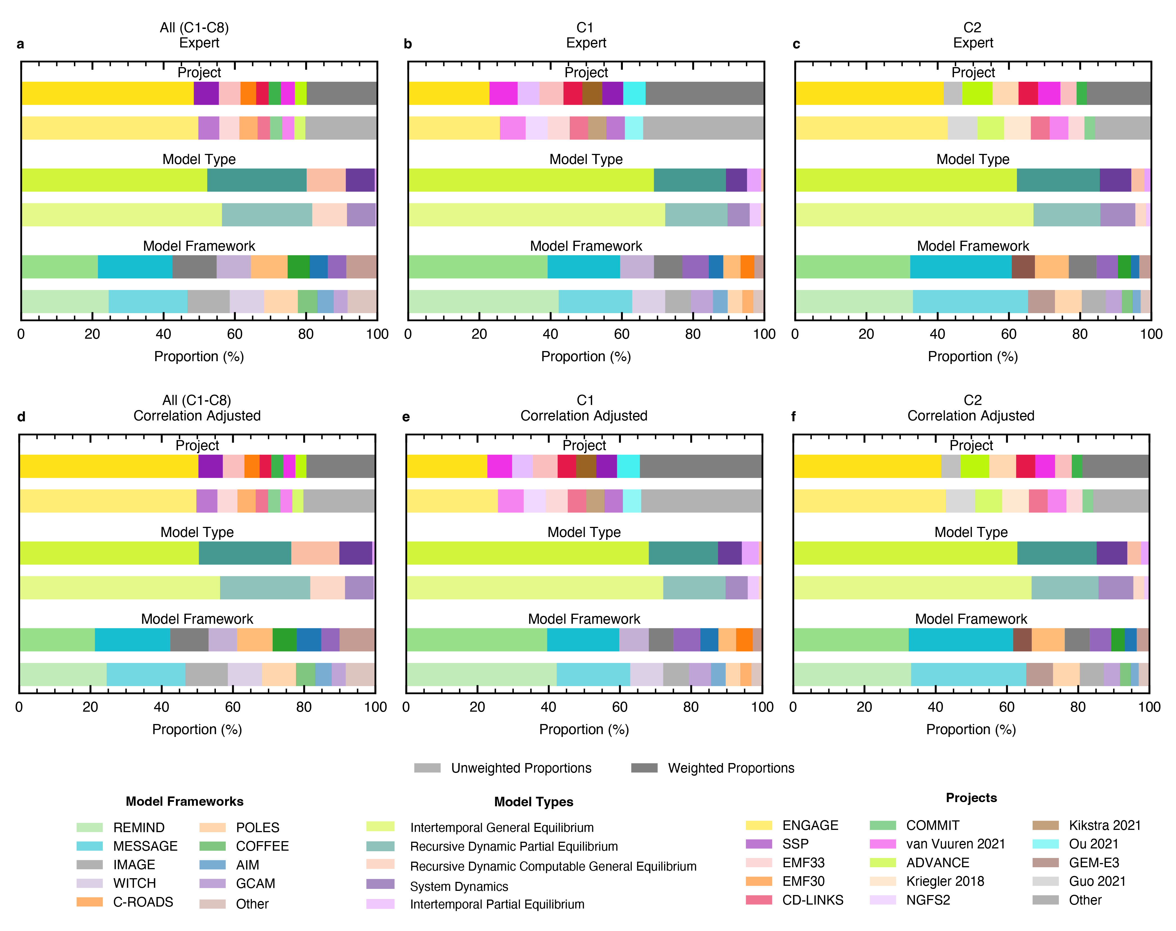

**Supplementary Figure 10 | How diversity reweighting impacts distribution of projects, model types and model frameworks in C1-C8, C1, and C2 scenarios.** Each panel displays the unweighted and weighted proportions of each project, model type and model framework for a subset of scenarios, and for a reweighting procedure. Panels a and d show C1-8 scenarios; panels b and e show C1 scenarios; and panels c and f show C2 scenarios. The top row of panels show sigma of 20th percentile of RCP-SSP model differences, see Supplementary Results 2) with our expert variable weighting. The second row of panels show the same sigma values but with our correlation adjusted variable weighting (see Supplementary Methods 1).

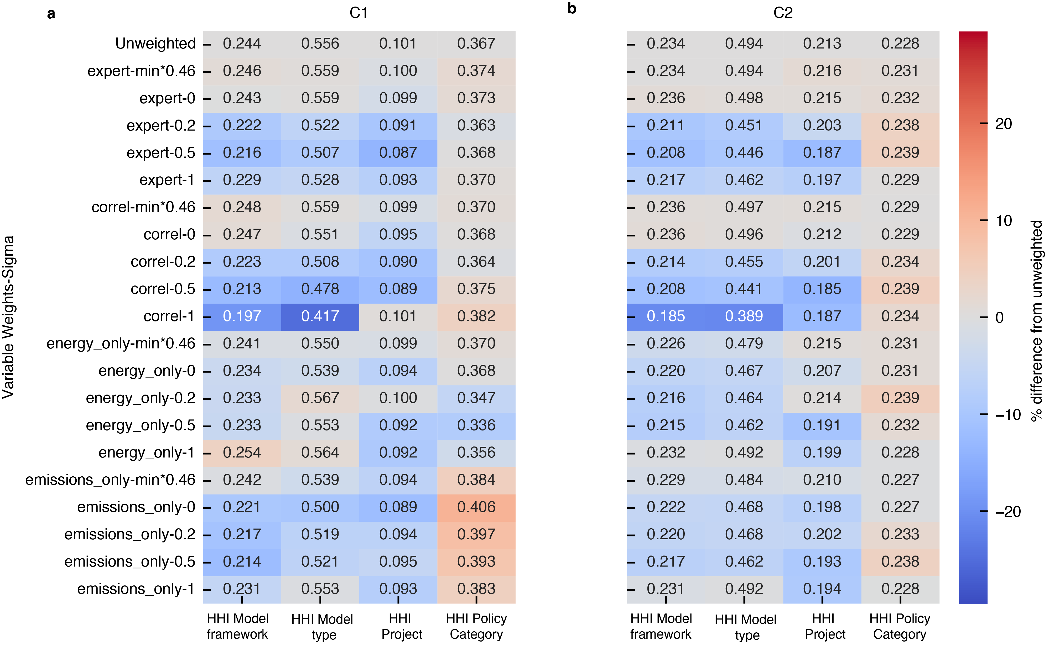

**Supplementary Figure 11 | Heatmaps showing impact of a range of weighting inputs on Herfindahl-Hirschman Index (HHI).** Lower scores indicate improved evenness of model framework, model type, project of policy category. For guidance on weighting examples tested, see Supplementary Results 2. Colours of heatmap cells are based on % difference in HHI value when compared to the unweighted equivalent in the top row. Panel **a** C1 scenarios, and panel **b** C2 scenarios.